FROM THE EDITOR
Jackie Walters

Happy New Year to all club members! The December edition of the Newsletter is a little shorter than usual since you’ve had a bumper edition of the club magazine – don’t want you to spend more time reading than running! If you have any articles for the Newsletter, ideas for the new Magazine or would like to write a regular feature, please email the Club. We would particularly welcome new contributors.

Just a reminder, the Newsletter looks back at the activities of the previous month. It is normally issued at the beginning of the following month, so in this case January, so that all the results for December can be included. It is a little late this time due to the holidays, the editor having just returned from the beautiful Gower Peninsular, (great runs on the coastal footpath), home just in time to escape the floods there!

This newsletter has been brought to you by John Cawley, Jen Stephenson, Denise Johnson, Quentin Lewis, Ian Ferris, Geoff Perigo, Paul Baildon, Sally Gavaghan and Dave Lonsdale. Thank you for your contributions. Please send contributions for the next Newsletter to news@baildonrunners.co.uk no later than 29 January 2016.

RUNNER OF THE MONTH
The November award will be presented as usual on Thursday evening before the club runs.

All members can nominate Runner of the Month. If you know anyone (including yourself!) who has achieved something special email your nomination to baildonrunners@yahoo.co.uk. It is not just about breaking records. It could be completing a first race, a particular distance or time. It doesn’t need to be running related and could include volunteering at events for instance.

Membership

We are pleased to welcome 3 new first claim members , Ian Dawson, Jane Sturgess and Sue Gallagher, (Sue has re-joined). This takes our membership up to 192.

Junior Park Run
by Jen Stephenson

I am pleased to announce that the inaugural Saltaire Junior parkrun will take place on 10th January 2016. It will start at 9am with a warm up taking place beforehand.

This is a timed 2k run for children aged 4-14 and will be three laps of the top section of Roberts Park. Children can run unaccompanied if they wish or can be accompanied by an adult. However, we ask adults not to cross the finish line.

Please can runners register with parkrun beforehand if they have not already. Details of how to register and more information can be found here http://www.parkrun.org.uk/saltaire-juniors/

Adult volunteers would also be very welcome. Please contact me at baildonrunners@yahoo.co.uk.if you can help.

Club Awards
by Ian Ferris

A big congratulation to our 2015 award winners and to all those who were shortlisted.

Best Newcomer Award
From the 43 eligible newcomers we shortlisted 9: Jennie Guard, Lee Kaznowski, Michael Malyon, Susanna Walters, Rob Myers, Col Morley, Agnes Illingworth, Mark Delaney and Ali Boyle and awarded the best newcomer to Michael who joined us in the summer of 2015.

Most Improved Award
Shortlisted were: Kirsty Allen, Ben Watson, Lee Kaznowksi, Rebecca Langdon, Michael Malyon, Nigel Shaw, Karen Baildon, Jo Bloor, Carolyn Hargreaves, Judith Wilson and our winner: Lee Kaznowski.
Outstanding Performance Award
The nominations included teams: the WYWL Ladies Team for Winning Baildon hosted event and Michael Malyon, Jennie Guard and Matthew Gurney for regaining the Mixed Team title for Baildon at the Washburn Valley relays.
Individual nominees were Jackie and Mick Cooper, Denise Johnson, Emma Stoney, Jenny Guard, Kirsty Allen, Dan Cobb, Judith Wilson, Jo Bloor, John Buddle and our winner Michelle Morris for her Marathon de Sables.
Turpin Trophy
This trophy is awarded to those how have made a special contribution to the club. Nominated were Alan Clements, Denise Johnson, Paul Baildon, Jackie Walters and Sally Gavaghan. Our worthy winner was Alan Clements and, as is traditional, Alan was not available to receive the trophy. We intend to present it before the run on Thursday 21st January and hope you can all make this.

Summer Championship Winners
The top three in the premier division were Jim Wheldon, Nigel Shaw and Ben Watson. In the first division, it was Jackie Walters, Sally Gavaghan and Elinor Newhouse and in the second division Lee Kaznowski, Mark Delaney and Karen Baildon. The Summer Championship shield is awarded to the runner with the most points overall and this year it was a draw, both Jim and Lee scoring 195 points and sharing the Shield.

Winter League and Summer Championship Trophies
We also presented trophies to the 12 runners who competed in all 5 Winter league races and to 21 runners who completed more than 6 summer championship races.

Can you Eat to Run?
by Sally Gavaghan

I listened to a report on Radio 4’s Food Programme entitled, “Can you Eat to Run?” on 4th January at 15:30pm. There is a follow up next month. There were several different opinions so it was difficult to draw conclusions but you might want to catch it on BBC iPlayer.

OGOBS CHRISTMAS HANDICAP
by Denise Johnson & John Cawley
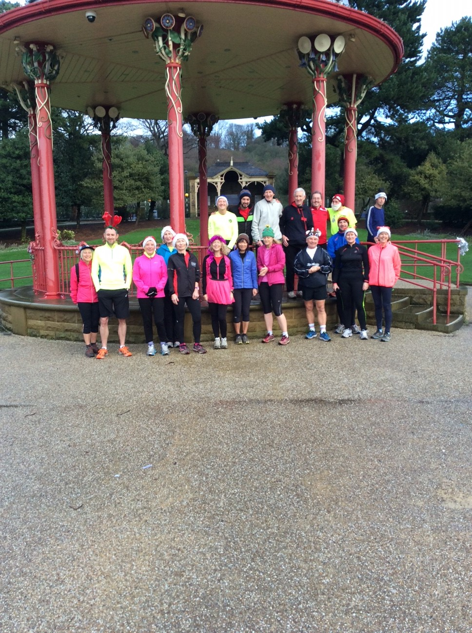
OGOBS ready for action 1

We were all out running along the canal on a typical OGOBS run with lots of chatting and laughter when I had this idea, why not have a Christmas handicap race? By the end of the run I had a date in mind, the 16th December, the week before I went away for Christmas.

Due to the recent rain we had to change the route at the last minute but I worked out that from Roberts Park and along the canal to the three rise locks and back would give us 5 miles without having to go along the riverbank. So we started the planning. You had to wear a silly hat and bring a secret Santa prize wrapped up and we would all exchange the gifts at the end. Just to make it a little more fun Don bought a trophy and the local shop in Baildon engraved it for us. All that was left was for me to work out the handicap times.

21 entries flooded in so the work began of looking up parkrun times and any other race I could find that my group had taken part in. The hardest part was working out how much start to give Dave Noble who only runs once a week now, but I got it wrong. The other runners went much faster than I predicted and by halfway Dave had lost his lead.

When you set off it’s hard not to go too fast as your natural instinct is to chase the person in front. Finally after 21 minutes Pete Gallagher, the last to set off, was on his way to chase us all down.

In my group I went off with Ian Hartman and Barbara Lee. Lots of chatting was taking place until just before half way when John Cawley passed us going like a train. Heading back down the canal Dave Lonsdale had taken quite a large lead and I shouted “winner” as he passed me. We had Jim Wheldon at the turn round point and we had to high five him before turning for the return journey.

It was only on my way back that I finally started to catch people and moved up into second place. Linda Carey had offered to be timekeeper and my friend Bob helped her. I must have got some of the timings correct as the runners started to stream in quick and fast. I did at one point think PHEW as John Cawley steamed past me - I think shouts of FIX would have been on the cards if I had won.

After the race we all congregated in the bandstand to shelter from the rain and presented the trophy to the winner. Now, I’ll pass on to the winner, John Cawley to complete the story …

I found myself starting 13 minutes after the first runner (Dave Noble) had set off. I hadn’t counted how many were ahead of me so when it was my turn to go I just targeted those who set off a minute before me. When I got on to the towpath I could see Barbara, Denise and Ian still grouped together, nobody else was in sight. I was chasing them quite hard but didn’t seem to be making any inroads into their lead, I found out later that Ian had been glancing round and encouraging the others to go faster to keep me at bay!

As we approached Bingley I finally caught the ‘gang of three’ and after staying behind them for a minute or so to gather myself I went by and picked a few more people off before I saw Dave Lonsdale whizzing by already on the homeward stretch. Head down I climbed the horrid incline at three rise locks to high five Jim Wheldon and make the turn for home. I accelerated down the incline and gradually caught a few more that turned before me; Dave Lonsdale, however, was out of sight. I was getting quite tired by now but eventually I spotted Dave crossing the bridge just after The Fisherman’s. This gave me fresh hope and gradually I reeled him in (sorry about the angling pun!).

I was elated to be in the lead but suddenly it dawned that much younger speed merchants such as Pete Gallagher and Jim Barnett would be chasing me down and for that matter the ever-improving Col Morley wasn’t that far behind me at the halfway turnaround point. I summoned up what energy I had left and pressed on not daring to look round. It was only when I got to Salts Mill to turn off the towpath that I dared to look round; phew nobody within catching distance, so I actually stopped for a brief moment to look again just to make doubly sure! My eyes weren’t deceiving me, I was in the clear so it was with a really stupid grin on my face that I trotted over the bridge and down the promenade to the finishing line adjacent to the bandstand where Linda and Bob were standing to shout me home. I couldn’t believe I’d done it and still can’t now. I know it was a low-key race, and a handicap one at that, but nevertheless I crossed the line first; the last time I had done so I was just 12 years old in an 80 yards hurdles race at school!
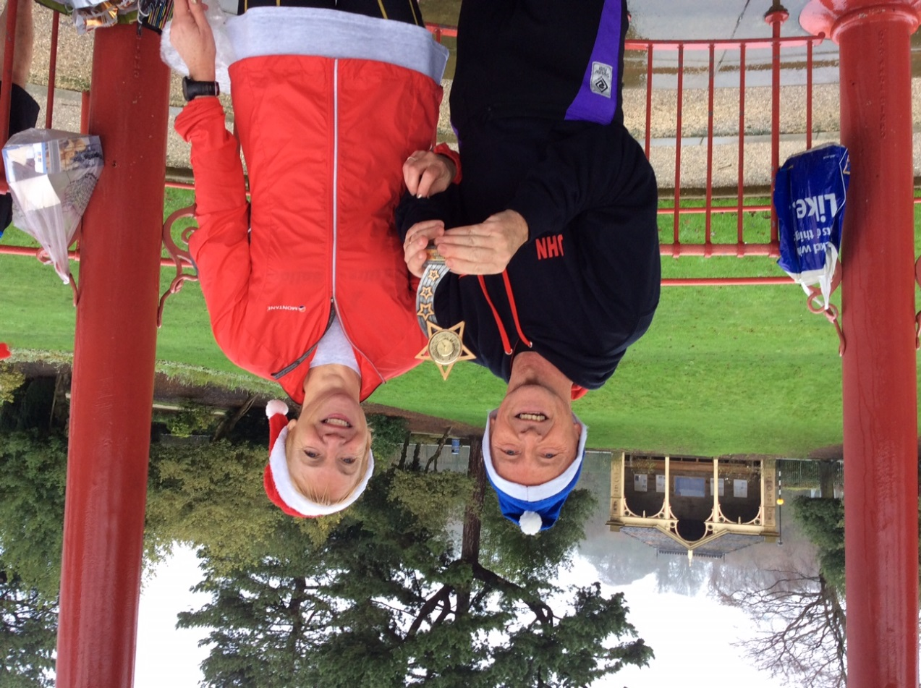
The Winner! 1

Strava
by Quentin Lewis
I have set up a Baildon Runners Club on Strava which you are most welcome to join. If you are interested, go to their website, https://www.strava.com, click on, “find or create a club” on the left of the screen and type Baildon Runners. You will then be able to join the group.
Strava is a community of athletes from all over the world, connecting and competing with each other via mobile and online apps. Strava lets you track your rides and runs via your iPhone, Android or dedicated GPS device and helps you analyse and quantify your performance.

Thursday B Group Run
by Paul Baildon
In recent years Group B has drifted towards virtually running with group A for most Thursday runs for one reason or another. We are now trying to re-establish a separate Group B to encourage the faster group C runners to make the step up whilst at the same time giving an option of a more comfortable run for those who might not feel up to a fast Group A pace. Anybody dropping down at present, to Group C, inadvertently ends up making this group too fast!
We are also sure there are numerous members who do not attend on a Thursday as there is not a pace between C and A/B. We hope this move will encourage you to come along on our main club night. There will be a designated group leader to keep the pace down which will be flexible on the night but is aimed at runners who are around 45 minutes for 10K.

AGE CATEGORY RECORDS
John Cawley

Full details of all age category records can, as usual, be accessed on the club website. Unless I’ve missed someone there doesn’t seem to have been any new records set to report in this issue.

RESULTS

Please continue to email your race results to results@baildonrunners.co.uk but note there is no need to do this for parkrun events or summer championship races unless you are not shown in those results as a Baildon Runner, for example if you entered the race before joining the club. However, could second claim members please email all their results including parkruns.

For those of you who don’t want to wait for the next newsletter, all Baildon Runners’ parkrun results can be viewed shortly after the relevant Saturday at www.parkrun.com/results/consolidatedclub/?clubNum=1854.

Firstly, a few ‘late’ and originally incomplete results:

Guy Fawkes 10 miles - 1 November
183rd | Graham Driver | 1:18:55
396th | Debbie Bland | 1:29:16
807 finishers.

Harewood 10 Mile Trail Race - 8 November
64th | Emma Stoney | 1:14:17
92nd | Alison Boyle | 1:18:11
205th | Debbie Bland | 1:30:26 | 1st F55
319 finishers.

Harewood 5 Mile Trail Race - 8 November
57th | Steve Tindall | 47:37
117 finishers.

Ravenstonedale 10K (Cumbria) - 28 November
89th | Debbie Bland | 51:59 | 1st F60
157 finishers.

Barnsley 10K - 29 November
182nd | Alice Buttle | 46:44
736 finishers.

Birkenhead 5K parkrun - 5 December
54th | Jim Goddard | 24:27
119 finishers.

Halifax 5K parkrun - 5 December
18th | Melanie West | 25:52 | 1st F40*
* also third female overall
41 finishers.

Horton Park 5K parkrun - 5 December
7th | Philip Jones | 24:57 | 2nd M55
40 finishers.

Lister Park 5K parkrun - 5 December
1st | Lee Kaznowski | 18:48
9th | Pete Gallagher | 21:07 | 2nd M40
15th | John Buddle | 21:45 | 3rd M50
30th | Gordon Slater | 23:23
35th | Nigel Shaw | 23:31
36th | Don Johnson | 23:35
44th | Donna Kaznowski | 23:55 | 2nd FU35
57th | Rob Myers | 24:53
70th | Martin Kieffer | 25:47
100th | Ellie Clement | 27:43
102nd | Jill Buddle | 27:49 | 2nd F50
144th | Elinor Newhouse | 31:40 | 1st F65
161st | Jane Sturgess | 34:03
167th | Sue Gallagher | 35:16
190 finishers.

Reindeer 5K (Saltaire) - 5 December
1st | Lee Kaznowski | 19:55
 | Mark Delaney | 21:30
 | Donna Kaznowski | 22:25
 | Sarah Terry | 27:06
 | Dave Lonsdale | 29:30
 | Sally Gavaghan | 30:00
 | Karen Butler | 30:00
 | Elinor Newhouse | 31:34
 | Janice Davidson | 34:44
 | Colin Davidson | 34:44
All timings self-timed.

Frostbite ‘30’ 34.5 miles, 5,500ft climb - 6 December
84th | Mick Cooper | 7:41:23
85th | Jacqueline Cooper | 7:41:24
137 finishers (26 DNF).

West Yorkshire Cross Country League Guiseley
6 December
22nd | Michael Malyon | 34:01
32nd | Quentin Lewis | 34:55
133rd | Don Johnson | 45:23
151 finishers.

Cross Flatts 5K parkrun - 12 December
20th | Don Johnson | 23:10 | 1st M60
40th | Denise Johnson | 25:17 | 1st F55
77 finishers.

Horton Park 5K parkrun - 12 December
3rd | John Buddle | 21:34 | 1st M50
31 finishers.

Lister Park 5K parkrun - 12 December
3rd | Lee Kaznowski | 19:06 | 1st MU35
7th | Ben Watson | 20:17 | 2nd M35
30th | Philip Jones | 23:32 | 2nd M55
34th | Donna Kaznowski | 23:43
37th | Col Morley | 23:53
124th | Dave Shaw | 28:58 | 1st M70
192nd | Jenny Stephenson | 35:46
198th | Neil Fairburn | 37:02
215 finishers.

Skipton 5K parkrun - 12 December
6th | Paul Dennison | 20:44 | 1st M55
32nd | Steve Tindall | 26:43 | 3rd M50
86 finishers.

Winter League - Dewsbury - 13 December
Men
4th | Michael Malyon | 297 pts | 2nd MU35
5th | Quentin Lewis | 296 pts | 2nd M40
17th | Gareth Holme | 284 pts
21st | Lee Kaznowski | 280 pts
32nd | Chris Burke | 269 pts
48th | Ben Watson | 253 pts
59th | Phil E Brown | 243 pts
74th | Andy Robinson | 227 pts
80th | Kevin Brain | 221 pts
82nd | Lorne McNeill | 219 pts
93rd | Paul Baildon | 208 pts
95th | Neil Fairburn | 206 pts
101st | Danny Miles | 200 pts
123rd | James Birkley | 178 pts
130th | John Buddle | 171 pts
133rd | Mark Delaney | 168 pts
142nd | Rob Myers | 159 pts | 3rd M60
158th | Ian Hartman | 143 pts
166th | Nigel Shaw | 135 pts
180th | Geoff Perigo | 121 pts
193rd | John Cawley | 108 pts
206 finishers.

Ladies
9th | Kirsty Allen | 292 pts | 3rd F40
12th | Anna Smith* | 289 pts | 1st F50
21st | Alice Buttle | 280 pts
22nd | Anna McMillan | 279 pts
26th | Liz Caven | 275 pts
32nd | Alison Boyle | 269 pts
33rd | Debbie Watson | 268 pts
47th | Donna Kaznowski | 254 pts
50th | Sarah Terry | 251 pts
69th | Karen Baildon | 232 pts
72nd | Sue Coates | 229 pts | 1st F65
84th | Sarah-Jane Templeman | 217 pts
85th | Tara Phillips | 216 pts
88th | Geraldine Ray | 213 pts
* representing Queensbury RC
90 finishers.

Team positions (out of 9) | Day
Ladies | 3rd
Men | 3rd
Veterans | 2nd
Overall | 2nd

Mytholmroyd 10K, 1,350ft climb - 13 December
35th | Mick Cooper | 1:05:40
83 finishers.

Leeds Christmas 10K Challenge - 13 December
79th | Robin Graham | 49:35
93rd | Philip Jones | 51:11
357 finishers.

OGOB Christmas Handicap 5 miles - 16 December
 |  | Run time | H’cap | Total time
1st | John Cawley | 41:29 | 13:00 | 54:29
2nd | Denise Johnson | 44:10 | 12:00 | 56:10
3rd | Barbara Lee | 44:22 | 12:00 | 56:22
4th | Col Morley | 42:30 | 14:00 | 56:30
5th | Dave Lonsdale | 50:43 | 6:00 | 56:43
6th | Don Johnson | 40:45 | 16:00 | 56:45
7th | Pete Gallagher | 35:55 | 21:00 | 56:55
8th | John Smithurst (G) | 46:39 | 10:30 | 57:09
9th | Sylvia Ross (G) | 49:24 | 8:00 | 57:24
10th | Jackie Walters | 51:04 | 7:00 | 58:04
11th | Suzanne Hague (G) | 49:35 | 8:30 | 58:05
12th | Sally Gavaghan | 49:38 | 8:30 | 58:08
13th | Jim Barnett | 38:16 | 20:00 | 58:16
14th | Ian Hartman | 46:38 | 12:00 | 58:38
15th | Sue Coates | 50:10 | 9:00 | 59:10
16th= | Elinor Newhouse | 57:40 | 4:00 | 1:01:40
16th= | Jane Sturgess | 59:40 | 2:00 | 1:01:40
18th | David Noble | 1:10:36 | 0:00 | 1:10:36
(G) signifies guest
18 finishers.

Graves (Sheffield) 5K parkrun - 19 December
143rd | Elinor Newhouse | 32:49 | 3rd F65
176 finishers.

Halifax 5K parkrun - 19 December
24th | Melanie West | 25:25 | 1st F40*
* also third female overall
61 finishers.

Horton Park 5K parkrun - 19 December
7th | Mick Cooper | 22:37 | 1st M50
17th | Jacqueline Cooper | 26:53 | 3rd F45
19th | Don Johnson | 27:36 | 1st M60
20th | Denise Johnson | 27:38 | 1st F55
39th | Linda Carey | 51:55 | 3rd F55
39 finishers.

Huddersfield 5K parkrun - 19 December
72nd | Alice Buttle | 22:06 | 2nd FU35*
* also third female overall
415 finishers.

Lister Park 5K parkrun - 19 December
4th | Lee Kaznowski | 19:03 | 1st MU35
7th | Chris Burke | 19:43 | 2nd M45
12th | Ben Watson | 20:24 | 3rd M35
22nd | John Buddle | 22:06
25th | Anna Smith | 22:36 | 1st F50*
34th | Donna Kaznowski | 23:09 | 1st FU35
91st | Steve Tindall | 26:45
128th | Dave Shaw | 28:59 | 1st M70
132nd | Karen Baildon | 29:13
150th | Jill Buddle | 30:25
199th | Jenny Stephenson | 35:45
* also second female overall
234 finishers.

Roundhay Park 5K parkrun - 19 December
76th | Col Morley | 25:24
215 finishers.

The Stoop 8K, 250 metres climb (Haworth)
20 December
29th | Michael Malyon | 37:08
88th | Malcolm McMillan | 41:07
162nd | Mick Cooper | 46:45
190th | Kevin Brain | 47:47
197th | James Birkley | 48:18
233rd | Anna McMillan | 50:19
242nd | Neil Fairburn | 50:46
244th | Gordon Slater | 50:48
261st | Rob Myers | 51:29
312th | Debbie Watson | 54:52
326th | Ian Hartman | 55:44
343rd | Jim Goddard | 56:23
384th | Geoff Perigo | 1:00:01
388th | Jacqueline Cooper | 1:00:34
398th | Kate Walter | 1:02:01
438th | Angela Pegg | 1:11:18
454 finishers (3 DNF).

Lister Park 5K parkrun - 25 December
8th | Lee Kaznowski | 19:30
24th | Jim Barnett | 21:24
34th | Neil Fairburn | 22:21
35th | Donna Kaznowski | 22:23
47th | Mick Cooper | 23:13
68th | Debbie Bland | 24:07 | 1st F60
101st | Melanie West | 26:01 | 2nd F40
107th | Jacqueline Cooper | 26:11 | 3rd F45
110th | John Crabtree | 26:17
122nd | Kate Walter | 27:07 | 3rd F55
147th | Steve Tindall | 29:00
158th | Paul Dennison | 29:41
177th | Dave Lonsdale | 31:06
191st | Elinor Newhouse | 31:31 | 1st F65
261st | Amanda Darbyshire | 38:11
291st | Linda Carey | 43:34
299 finishers.

Chevin Chase 7 miles (approx) - 26 December
12th | Michael Malyon | 44:05
61st | Gareth Holme | 49:53
62nd | Ben Watson | 49:50
107th | Paul Dennison | 52:25
135th | Paul Baildon | 53:53
180th | David Long | 56:09
184th | Lorne McNeill | 56:23
185th | Danny Miles | 56:25
215th | Andrew Price | 57:53
250th | Darren Jukes | 59:12
281st | Jim Barnett | 59:41
294th | Paul Thomas | 1:00:35
300th | Gordon Slater | 1:00:48
329th | Neil Fairburn | 1:01:22
348th | Catherine Milner | 1:02:59
356th | Rob Myers | 1:03:11
371st | Liz Caven | 1:04:00
410th | Stephen Brown | 1:05:07
422nd | Michelle Morris | 1:05:38
439th | Melanie West | 1:05:57
584th | Debbie Bland | 1:11:59 | 2nd F60
603rd | Karen Baildon | 1:12:58
636th | Steve Tindall | 1:14:24
737th | Sally Gavaghan | 1:24:53
778th | Jackie Walters | 1:33:46
779th | Susanna Walters | 1:33:47
797 finishers.

Lister Park 5K parkrun - 26 December
6th | Lee Kaznowski | 19:41 | 3rd MU35
29th | Col Morley | 24:09 | 3rd M45
89th | Jenny Stephenson | 35:22
101 finishers.

Scunthorpe 5K parkrun - 26 December
77th | Ian Hartman | 24:51 | 2nd M65
242 finishers.

Auld Lang Syne 9.6K, 300m climb - 31 December
86th | Ben Watson | 55:28
171st | Kevin Brain | 1:00:40
187th | Andrew Price | 1:02:01
217th | Dan Cobb | 1:04:02
262nd | Gordon Slater | 1:07:37
311th | Rob Myers | 1:11:05
327th | Ian Hartman | 1:12:17
361st | Tony Deacon | 1:17:02
377th | Kate Walter | 1:20:36
403rd | Angela Pegg | 1:32:45
413 finishers (6 DNF).

Horton Park 5K parkrun - 1 January
14th | Jim Barnett | 21:39
17th | Neil Fairburn | 22:31 | 3rd M50
36th | Debbie Bland | 25:06 | 1st F60*
58th | Don Johnson | 29:30 | 2nd M60
59th | Denise Johnson | 29:33 | 1st F55
69th | Elinor Newhouse | 32:53 | 1st F65
87th | Dave Lonsdale | 51:29
88th | Amanda Darbyshire | 51:30
89th | Melanie West | 51:32
* also second female overall
91 finishers.

Giants Tooth 3 miles, 394ft climb - 1 January
17th | Malcolm McMillan | 20:25
34th | Mick Cooper | 23:10
37th | Anna Smith | 23:25
38th | Jim Wheldon | 23:34
44th | Neil Fairburn | 24:18
67th | Rob Myers | 26:27
71st | Philip Jones | 26:44
96th | Anna McMillan | 30:35
116 finishers.

Halifax 5K parkrun - 2 January
18th | Philip Jones | 24:47 | 3rd M55
70 finishers.

Horton Park 5K parkrun - 2 January
11th | Debbie Bland | 24:21 | 1st F60
17th | Don Johnson | 26:05 | 1st M60
18th | Denise Johnson | 26:06 | 1st F55
50th | Linda Carey | 45:44
50 finishers.

Lister
Park 5K parkrun - 2 January
2nd | Michael Malyon | 17:35 | 1st MU35
11th | Lee Kaznowski | 19:16
22nd | Pete Gallagher | 20:17 | 2nd M40
25th | Ben Watson | 20:42
31st | Jim Barnett | 21:29
46th | John Buddle | 22:18
78th | Donna Kaznowski | 23:47
116th | Melanie West | 26:04 | 1st F40
190th | Jill Buddle | 28:44 | 2nd F50
240th | Tara Phillips | 30:33
249th | Dave Lonsdale | 30:52
294th | Shelagh Hopkinson | 33:30 | 2nd F60
297th | Richard Lund | 33:38
302nd | Amanda Darbyshire | 33:52
310th | Jenny Stephenson | 34:42
318th | Sue Gallagher | 35:01
372nd | Malcolm Sharp | 39:56 | 1st M70
390 finishers.

Dates of Forthcoming Races 2016

Every Saturday morning at 9:00 | Lister Park 5K parkrun (Bradford), Hyde Park 5K parkrun (Leeds),  Horton Park 5k parkrun (Bradford)  Roundhay Park 5K parkrun (Leeds), Temple Newsam 5K parkrun (Leeds), Cross Flatts Park 5K parkrun (Beeston, Leeds)  All are free events, but you must pre-register online by 6:00pm Friday, and take the barcode emailed to you.
10 January | Garstang 10K
17 January 2016 | Brass Monkey Half Marathon (York)
17 January | Inskip Half Marathon (nr. Preston)
31 January | Winter League (Temple Newsam)
31 January | Meltham 10K
7 February | Dewsbury 10K
14 February | Liversedge Half Marathon
7 February | Muddy Boots 10K (Ripon)
14 February | Wombwell 5 miles
21 February | Great North West Half Marathon (Blackpool)
28 February | Huddersfield 10K
28 February | Winter League (Pudsey)
13 March | Spen 20 miles (Cleckheaton)
13 March | WYWL v PECO
20 March | East Hull 20 miles
20 March | Trimpell 20 miles
 | South Yorkshire Half Marathon (Goldthorpe, nr. Rotherham)
13 March | Sweatshop 10 miles (St. Annes)
 | Bradford 10K
19 March | Coniston 14 miles
20 March | Thirsk 10 miles
20 March | Garstang Gallop 10K
6 March | Keighley Big K 10K
3 April | Baildon Boundary Way  KEEP THIS DATE FREE!
10 April | Manchester Marathon
24 April | Blackpool Marathon
24 April | Blackpool Half Marathon
24 April | Virgin London Marathon
9 April | Wensleydale Wander 12 miles or 22 miles (Leyburn, N. Yorks)
 | Guiseley Gallop 10K (approx)
 | Bunny Run Relays 1.5 m 200 ft ascent teams of 3 , enter on night only
 | Fountains 10k (Grantley nr Ripon)
 | Bluebell Trail 10.3 miles (West Vale, Stainland)
8 May | Leeds Half Marathon
11 September | Great North Run
9 October | Plusnet Yorkshire Marathon (York)

COMMITTEE MEMBERS
Ian Ferris Secretary, Club Coach, Beginners, Run England and BAN Rep
Paul Baildon Treasurer
Dave Lonsdale Membership Secretary and Curry Nights
Kevin Brain Quarterly Magazine
Sue Coates Carnival Canter and Kit
Dan Cobb Announcements and WYWL Rep
Matthew Gurney Development Group Link and AA Link
Gareth Holme Men’s Relay Team Captain
Geoff Perigo Webmaster, Club Diary and Routes
Lizzie Smith Minutes
Geraldine Ray Social Secretary
Emma Stoney Ladies’ Relay Team Captain
Jeremy Smith Summer Championship
Jackie Walters Newsletter Editor, Leaders for D,E and Sunday runs

OTHER CONTACTS WEBSITE AND EMAIL ADDRESSES
Catherine Milner Club Auditor Website: baildonrunners.co.uk
Richard Barnes Garmin Routes General Email: baildonrunners@yahoo.co.uk
John Cawley Club Records and Results Newsletter email: news@baildonrunners.co.uk
Alan Clements Joint Club Liaison Results email: results@baildonrunners.co.uk
Denise Johnson Veterans Boundary Way email: baildonboundaryway@gmail.com
Anna Smith Off-Road Leagues
Emma Stoney Baildon Boundary Way Director

