FROM THE EDITOR
Jackie Walters

This newsletter has been brought to you by John Cawley, Ian Ferris, Sally Gavaghan, Jen Stephenson, Geraldine Ray, Sue Coates and Steve Pickard. Thank you for your contributions, a lot about the floods and even a poem this time! Please send contributions for the next (including more poems) to baildonrunners@yahoo.co.uk. by 26 February.

RUNNER OF THE MONTH
November’s worthy winner went to Malcolm Mc Millan for coming 16th out of 81 runners in the 9.3 miles Wadsworth Trog, in a time of 1.31.07, well done Malcolm! The December award will be presented as usual on Thursday evening before the club runs.

All members can nominate Runner of the Month. If you know anyone (including yourself!) who has achieved something special email your nomination to baildonrunners@yahoo.co.uk. It is not just about breaking records. It could be completing a first race, a particular distance or time. It doesn’t need to be running related and could include volunteering at events for instance.

ANNUAL GENERAL MEETING
Ian Ferris and the Committee

This is advance notice that the 2016 AGM will be held at Baildon Rugby Club on Thursday 17 March at 8.30pm. We encourage you all to attend and need 20% of (first claim) members for a quorum.

We will have a shorter run that night and will seek to provide food and drink to encourage you to attend. Saint Patrick's Day fancy dress is welcome.

As some of you may be aware England Athletics have further increased their fees and this now takes almost two thirds of your membership fees with only the remainder being kept by the club. At the AGM we will therefore be tabling a proposal to change our fees for the 2016-2017 running year. We also will table a minor change to the club constitution. Want to know more? Make sure you attend the AGM.

If you have any matters you wish to raise formally at the AGM please email these and start the subject line with “AGM” preferably by the end of February, at the absolute latest by 3 March.

We would very much welcome anyone who’d like to join the committee so if you have a specific role in mind or want to know more just ask any committee member. See you all on 17 March!

THE TURPIN TROPHY

Sue Coates presented Alan Clements with the Turpin Trophy. The Dave Turpin Trophy is awarded annually at the Christmas party but since Alan wasn't able to attend the party the presentation was made prior to a regular Thursday evening session.

The trophy, in memory of one of our past members, is awarded to a Club Member who has made a massive contribution to the club over the years. Often this has been for organising teams, socials, administering club events like the Baildon Boundary Way, producing the newsletter, increasing the profile of the club and too many other examples to mention. The trophy may only be awarded once to any member.

Alan was race director for several years for the Baildon Boundary Way and Sue reminisced on some of the issues he had dealt with, including a complaint about a number of men peeing in Esholt woods. When asked for their race numbers the complainant responded that she didn’t get the chance to look at race numbers as her attention was focused a bit lower! Alan of course sorted this out with his usual aplomb.

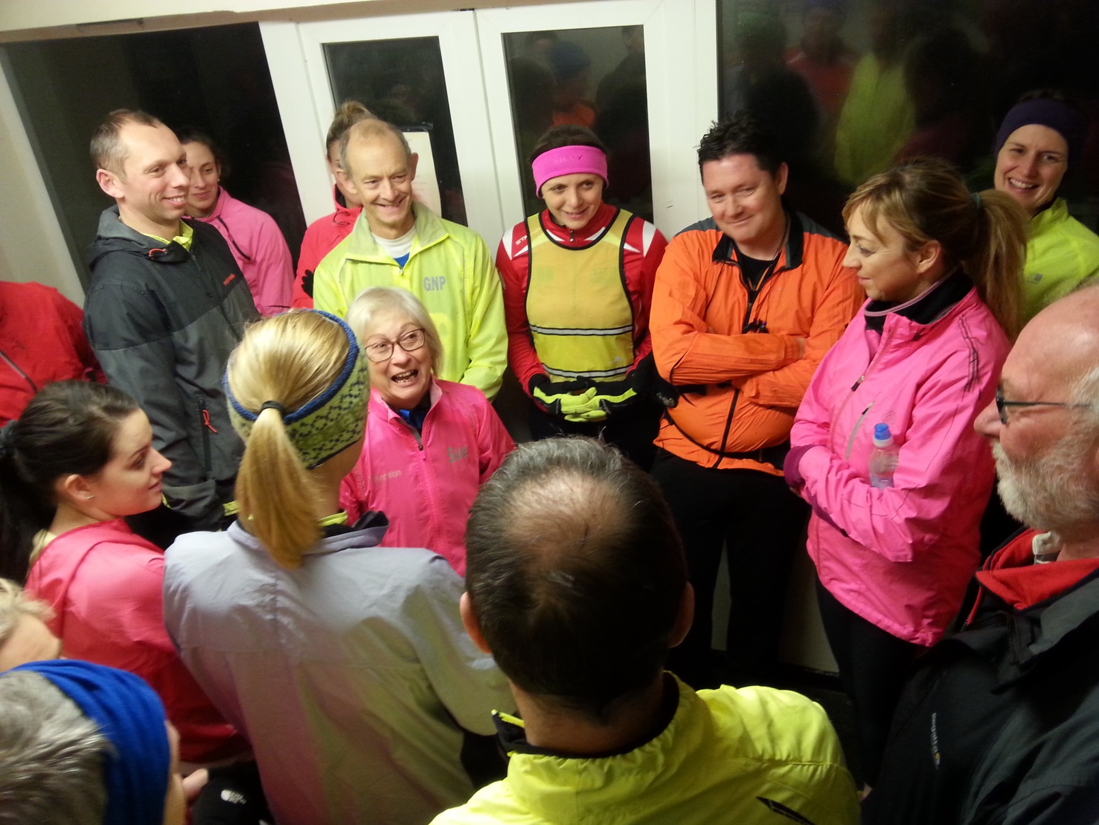
Sue tells the tale as Alan looks on

JUNIOR PARK RUN
by Saltaire Junior Park Run Team
A cold and wet morning welcomed the first Saltaire junior parkrun on 10 January. However this did not deter 169 first timers from running 169 Personal Bests! After a downpour at 8:55am to accompany an enthusiastic warm-up the clouds cleared to reveal the sun. There were lots of parents to cheer on the juniors and some even had a go at the course themselves.
The second event saw much better weather. A dry, mild morning saw 148 runners complete the course, 86 of them being first timers. An amazing 42 new Personal Bests were set.
It was good to see a lot of Baildon Runners amongst the volunteers who ensured everything went smoothly. If you would like to volunteer please contact saltaire-juniorshelpers@parkrun.com.
Please can runners register with parkrun beforehand if they have not already. Details of how to register and more information can be found at: http://www.parkrun.org.uk/saltaire-juniors/

LONDON MARATHON CHRISTMAS DRAW
by Geraldine Ray

One of the highlights of the Club Christmas party was the London Marathon ballot. Those who were unsuccessful in the London Marathon ballot had a second opportunity to win one of 2 places allocated to the Club. The first draw was for those who had never done the London Marathon before, and there were 12 hopefuls. Dave Long was the lucky winner. All these names were then added to the second draw and Ben Watson secured the second place. Ben is also a London Marathon first timer. We wish Dave and Ben well in their training.

RIVER AIRE FLOODS

Bradford Amateur Rowing Club has advised us of the degradation of the riverbank path between their clubhouse and Seven Arches. Runners please take extra care! Currently work is being done on the weir outside the clubhouse and the path has been re-routed round the back of the buildings. The route up to seven arches (the aquaduct) is passable with care.

THE AIRE VALLEY DEBRIS REMOVAL INITIATIVE

You will have seen that the recent floods deposited a vast amount of debris along the banks of the River Aire. A network of volunteers have formed the Aire Debris Removal Initiative and meet on Sundays to clean up the river banks. They would welcome anyone who would like to join them. They have had a great response so far - at Hirst Wood 22 bags were filled in under 2 hours. Sturdy boots and gloves are essential. A limited number of litter pickers and refuse sacks are provided by Bradford Council and volunteer canoeists help with river safety.

Events are weather dependent and cancelled if water levels too high or the weather too severe – the Facebook page has updates, www.facebook.com/airedri or contact airedri@gmail.com to be added to the mailing list.

Next up, an unusual race report …. THE CHEVIN CHASE

by Sally Gavaghan

You've probably all heard, I bet,
The "Chevin Chase" was a little bit wet.

That morning, I went without a care,
Through Roberts' Park in Saltaire
To Jackie's house, to meet up there.

So, walking through the park that day,
What a shock, what can I say?

Oh no! I've not seen this before!
The river's up to the Half Moon door.

At Baildon Bridge there was no way through,
Oh ‘ecky thump! What should we do?

Our driver, Susanna, Jackie's daughter,
Drove through deep and dangerous water,
Over the moors as fast as she dared,
We were all nervous, we were all scared.

Will it be cancelled? Will we be late?
Our hearts were racing,
We were in a state.

Then stuck in traffic, a very long queue,
We had to wait, we needed the loo.

Alas I'm sorry now to say,
We didn't make the start that day,
But we did the race anyway!

What an experience to remember,
Of this day in cold December.

Through floods and torrents and mud so thick.
We all agreed it was fan- tas- tic !!
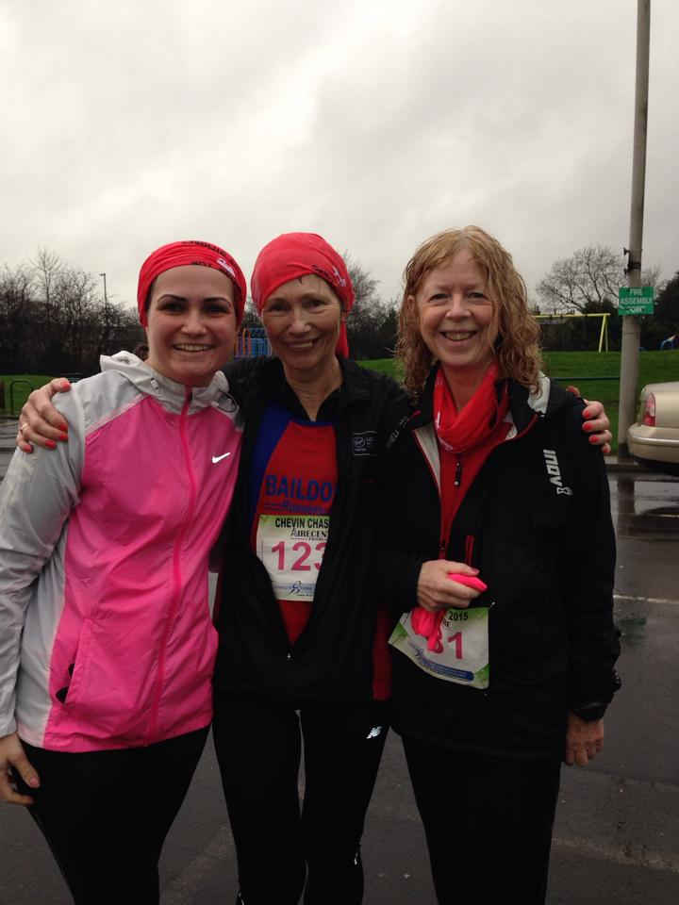

And another run on flood –hit Boxing Day run, with a dramatic conclusion!

MY BOXING DAY RUN
Steve Pickard

Boxing Day turned out to be EXTREMELY wet. Nevertheless I thought it would be interesting to go for a long run across the moors. Bingo, our super fit Parsons (long legged) Jack Russel did not seem phased by the weather either so when he started running round in excited circles, as I put on my running gear, I decided to take him along.

Describing the conditions as wet was an understatement as I headed to Hawksworth followed by a circuit which included Menston, Bleach House and Burley Woodhead. The way back included crossing a short section of the moors, 100m right on the main road then left down a farm track which eventually drops down to a small stream which you cross by means of a stone wall, up a short track on the other side to a farm near the top of Sconce Lane. The only thing is the small stream had turned into a complete torrent resembling The Strid at Bolton Abbey and which I now estimate to have been about 5 feet deep. The water was flowing about a foot over the top of the stone wall that you normally use to cross the stream. I realised there was no chance of walking across the wall as it was too slippery and my feet would washed straight off. Possibly as a result of an imbalance in my TV viewing, having watched too much Bear Grills and not enough Casualty, I decided to wade across. Carrying Bingo on my shoulders I set off and realised when the water was up to the top of my legs and I could feel its intense force that this was not a good idea.

My legs were washed away, I was swept sideways and my left shoulder smashed against the wall. I was then pulled down and held underwater. Such was the force of the water that I could not push myself back from the wall a single inch. After what was probably only a couple of seconds but felt much longer a current of water got under the right side of my running jacket filling the arm and body and nearly pulling it over my head. This dragged me forward and propelled me under the arch of the stone wall/bridge and shot me out into the river. I was then tumbled along but managing to grab quick breaths of air when my head broke the surface. At this stage I was over to the right hand side of the river. After about 30 or 40 metres I saw a branch and grabbed it with my right hand. It pulled on my arm socket as I abruptly came to a halt. For the next few minutes I hung on with my right hand as my body was being pulled horizontally in the direction of flow. I looked down the river and saw that where it narrowed it became faster and rougher and dropped away between some rocks. I realised that if I let go Bet Fred would not give me very good odds. I could not use my left arm but managed to get my left foot onto the bank and wiggle my way up the mud out of the water.

I realised my left shoulder was badly dislocated and/or broken. I was in agony and walked slowly forward bent over supporting my left arm and crying for help. It was then that I heard Bingo barking from the other side of the river and realised that he was fine. I had envisaged him being bashed against the rocks and had been wondering what on earth I was going to say to my daughter who 'officially ' owns Bingo. I managed to stagger up the track to Sconce Lane where I met a woman loading her dog into a car. She offered me a lift home. At this moment Bingo flew past like a well programmed cruise missile heading for home. I shouted after him at the top of my voice but he only had one thing in mind - getting home. The lady said to me 'you'll have to shout louder’. I got all my energy together, tried to ignore the pain from my shoulder and shouted 'Bingo!' Finally he turned round and headed back.

We got in her car with me in the front doubled over trying to cradle my arm. The lady was very kind, very helpful and very chatty but I wasn’t really able to appreciate the conversation due to the excruciating pain in my shoulder. Finally we got home. My younger daughter phoned 999 and got transferred to the ambulance section. I explained what had happened and told them I had a dislocated shoulder, possibly fractured and was in agony. Nevertheless they said it was not life threatening, could not send an ambulance and transferred me to 111. Well the questions they asked me were just too ridiculous to repeat but when I abbreviated my story to just being swept off a bridge they asked me if I had made any suicide attempts over the last 12 months!

The woman who gave me the lift heard the discussion and saw my right hand gripped around the phone just about on the point of leaving an imprint. She offered us a lift to BRI. We went into Shipley which was closed off due to flooding so we turned round and went via Bingley. Eventually we arrived at BRI. I staggered into triage. They took down some details, sat me in a wheelchair and within the space of 3 to 4 minutes I was in an emergency room being given gas and air and fitted with a cannula in my right arm into which they injected morphine.

Within a few minutes I was surrounded by a consultant, a doctor and a radiographer with a portable x ray machine. A few minutes later they had the x rays which showed dislocation and fracture of the joint. The morphine had started to take effect but the pain was still pretty intense. The doctor explained that they needed to stretch my arm out to manipulate the joint back into position. An assistant held my shoulders back while he tried to stretch my arm. It clicked a couple of times but hurt more than ever and he confirmed it was not fully back in. He said I might need a general anaesthetic to relax the muscle more. Just then the consultant came back. We chatted a bit. It turned out we were exactly the same age, that he was Irish and that his sport was rugby. I joked that on the rugby field they seem to just pop it back in. He agreed but said that they generally haven't got fractured shoulders and aren't 58. He said he didn't like using general anaesthetic if there's an alternative. I said to him 'so what we're talking about is me concentrating on relaxing the muscle more and you pulling harder'. He said 'that's about it but it will be very painful'. For some unknown reason maybe thinking I was Bear Grills again I said 'no problem'. He suggested Tamara went to the waiting room.

He told me to take deeper breaths of the gas and air. The other doctor came back and held my shoulders while the Irish consultant held my arm. This time he told the doctor gradually to lower the back of the bed while he maintained his position with my arm. I took massive breaths from the gas and air concentrating on nothing but my breathing and trying to relax. My mind turned inwards onto my breathing until I was almost oblivious of anything else. I had managed to put myself in the zone. I felt the pulling, felt the bed being lowered and felt him rotate my arm slightly before releasing the tension as it slid smoothly back into position. I made no noise at all. He announced that it was back in. I thanked him and he said that I'd done very well. I was discharged with pain killers, a sling and an appointment for the fracture clinic.

A week later I was in the fracture clinic where X rays showed that the outer part of the ball, the greater tuberosity, where the muscles attach, had broken off in three pieces. I was booked in for an operation and a week later had a two and a half hour open surgery operation on my shoulder in which three anchors were sunk into the ball to reattach the pieces of the greater tuberosity and the ripped off tendon re-attached.

My arm has to stay in the sling for 3 to 4 weeks for the bone to knit around the anchors and wire. After this I will need 2-3 months of movement physio followed by 12 months of strength rehab physio to get the movement back. If I do not work very hard at this the arm would be severely restricted and not move to above shoulder level. The hospital physio seems very good but the sessions are only 20 minutes every so often. I am looking for a specialist shoulder rehab physio and a bodybuilding club so I can rehab and develop my shoulder muscles as much as possible to give myself a chance of success.

My daughters have been very helpful and supportive as has everyone else but when you're used to being fit and healthy it's difficult to be grateful when the girl at Costa offers to carry your coffee to the table! When I described my incident to one person she said I'd been given a second life. If that is the case let's hope I can be a bit more careful with it than the first one!

If the lady who came to my rescue in my hour of need ever gets to read this I would like to express my most sincere thanks and gratitude for her time and support.

NEW WINTER KIT H1 VIZ TRAINING TOPS.

The price of £27 includes your initials on the front and baildonrunners.co.uk on the back in a reflective material. The tops are in pink for women , yellow for men . See the Baildon Runners website for pictures and more details – (select Club Shop from the menu on the left of home screen). For advice on sizes and to order contact Sue Coates : Sue@baildonrunners.co.uk

AGE CATEGORY RECORDS
John Cawley

Full details of all age category records can as usual be accessed on the club website. Unless I’ve missed someone there doesn’t seem to have been any new records set to report. This is the second consecutive quiet month!

RESULTS
John Cawley

Please continue to email your race results to results@baildonrunners.co.uk but note there is no need to do this for parkrun events or summer championship races unless you are not shown in those results as a Baildon Runner, for example if you entered the race before joining the club. However, could second claim members please email all their results including parkruns.

For those of you who don’t want to wait for the next newsletter, all Baildon Runners’ parkrun results can be viewed shortly after the relevant Saturday at www.parkrun.com/results/consolidatedclub/?clubNum=1854.

Winter League - Idle - 3 January
Men
4th | Michael Malyon | 297 pts | 2nd MU35
5th | Quentin Lewis | 296 pts | 2nd M40
21st | Lee Kaznowski | 280 pts
31st | Gareth Holme | 270 pts
37th | Chris Burke | 264 pts
42nd | Malcolm McMillan | 259 pts
56th | Ben Watson | 245 pts
66th | Phil E Brown | 235 pts
68th | James Bryson | 233 pts
72nd | Jim Barnett | 229 pts
73rd | Pete Gallagher | 228 pts
82nd | Danny Miles | 219 pts
84th | Andy Robinson | 217 pts
102nd | Rob Martin | 199 pts
104th | Mick Cooper | 197 pts
106th | Paul Baildon | 195 pts
111th | David Long | 190 pts
119th | James Birkley | 182 pts
129th | Dan Cobb | 172 pts
134th | Neil Fairburn | 167 pts
145th | Mark Delaney | 156 pts
162nd | Jim Wheldon | 139 pts | 2nd M60
170th | Rob Myers | 131 pts | 3rd M60
180th | Col Morley | 121 pts
184th | Ian Hartman | 117 pts
203rd | Geoff Perigo | 98 pts
213th | Steve Brown | 88 pts
221st | John Cawley | 80 pts
229 finishers.

Ladies
6th | Kirsty Allen | 295 pts | 3rd F40
7th | Emma Stoney | 294 pts | 2nd F35
10th | Anna Smith* | 289 pts | 1st F50
23rd | Alice Buttle | 278 pts
27th | Catherine Milner | 274 pts
40th | Liz Caven | 261 pts
45th | Debbie Watson | 256 pts
46th | Alison Boyle | 255 pts
52nd | Michelle Morris | 249 pts
54th | Charlotte Gibson | 247 pts
57th | Donna Kaznowski | 244 pts
63rd | Rebecca Langdon | 238 pts
70th | Helen Compton | 231 pts
71st | Barbara Lee | 230 pts | 2nd F60
80th | Carolyn Hargreaves | 221 pts
82nd | Sarah Terry | 219 pts
88th | Karen Baildon | 213 pts
92nd | Emma Long | 209 pts
100th | Sue Coates | 201 pts | 2nd F65
101st | Sarah-Jane Templeman | 200 pts
110th | Geraldine Ray | 191 pts
* representing Queensbury RC
112 finishers.

Team positions (out of 11) | Day | Cumulative
Ladies | 2nd | 2nd
Men | 3rd | 3rd
Veterans | 2nd | 2nd
Overall | 2nd | 2nd

Filey Flyer 23 muddy miles - 9 January
Jacqueline Cooper | 4:09:00
Mick Cooper | 4:09:00
No official results available.

Horton Park 5K parkrun - 9 January
13th | Debbie Bland | 23:55 | 1st F60
15th | Philip Jones | 24:03 | 2nd M55
23rd | Ian Hartman | 25:08 | 2nd M65
41st | Linda Carey | 32:28 | 2nd F55
57 finishers.

Lister Park 5K parkrun - 9 January
6th | Lee Kaznowski | 19:05 | 3rd M35
11th | Ben Watson | 20:22
17th | Jim Barnett | 20:48
25th | Rob Martin | 21:25 | 1st M55
42nd | Neil Fairburn | 22:26
48th | Donna Kaznowski | 22:43
49th | Don Johnson | 22:47 | 2nd M60
71st | Gordon Slater | 24:02
102nd | Col Morley | 25:11
113th | Michelle Morris | 25:38
132nd | Melanie West | 26:06
178th | Steve Tindall | 27:13
179th | Richard Lund | 27:14
210th | Helen Christie | 28:15
222nd | Sarah Terry | 28:29
243rd | Jane Clough | 28:54
254th | Sarah-Jane Templeman | 29:16
263rd | Denise Johnson | 29:37
293rd | Karen Baildon | 30:54
305th | Elinor Newhouse | 31:29 | 1st F65
306th | Karen Butler | 31:29
316th | Amanda Darbyshire | 31:40
362nd | Shelagh Hopkinson | 33:32 | 2nd F60
372nd | Dave Lonsdale | 34:06
374th | Susanna Walters | 34:11
380th | Janice Davidson | 34:34 | 3rd F60
382nd | Colin Davidson | 34:38
451st | Malcolm Sharp | 40:32 | 1st M70
485 finishers.

Marple (Stockport) 5K parkrun - 9 January
20th | John Buddle | 23:17 | 3rd M50
149 finishers.

Temple Newsam 10 miles - 10 January
153rd | Robin Graham | 1:23:30
250th | Denise Johnson | 1:29:06 | 3rd F55
265th | Debbie Bland | 1:30:09
409th | Pete Gallagher | 1:39:22
644 finishers.

Horton Park 5K parkrun - 16 January
37th | Linda Carey | 32:16 | 2nd F55
54 finishers.

Lister Park 5K parkrun - 16 January
3rd | Lee Kaznowski | 18:39 | 1st M35*
12th | Ben Watson | 20:07 | 2nd M35
27th | Rob Martin | 21:36 | 1st M55
28th | Donna Kaznowski | 21:42 | 2nd FU35#
41st | Don Johnson | 22:38 | 1st M60
45th | Gordon Slater | 22:44
141st | Steve Tindall | 26:53
154th | Helen Christie | 27:09
164th | Jill Buddle | 27:34 | 1st F50
196th | Jane Clough | 28:40
219th | Tara Phillips | 29:24
227th | Col Morley | 29:36
241st | Denise Johnson | 30:00
264th | Amanda Darbyshire | 31:46
271st | Shelagh Hopkinson | 32:21 | 2nd F60
291st | Sue Gallagher | 33:50
316th | Jenny Stephenson | 36:06
* also second male overall
# also second female overall
386 finishers.

Brass Monkey Half Marathon (York) - 17 January
143rd | Lee Kaznowski | 1:24:15
826th | John Cawley | 1:48:07
1,515 finishers (5 DNF).

Stanbury Splash 5 miles, 800ft climb - 17 January
130th | Jim Wheldon | 45:50 | 1st M60
153rd | Andrew Price | 47:29
170th | Neil Fairburn | 48:54
205th | Rob Myers | 52:17
221st | Ian Hartman | 53:21
250th | Geoff Perigo | 57:32
253rd | Jim Goddard | 58:22
263rd | Kate Walter | 1:00:55
277 finishers.

Horton Park 5K parkrun - 23 January
9th | Don Johnson | 22:38 | 1st M60
33rd | Linda Carey | 31:56 | 1st F55
45 finishers.

Lister Park 5K parkrun - 23 January
3rd | Lee Kaznowski | 18:38 | 1st M35
11th | Ben Watson | 20:12 | 2nd M35
27th | Rob Martin | 21:09 | 2nd M55
31st | John Buddle | 21:26 | 3rd M50
36th | Donna Kaznowski | 21:43 | 2nd FU35*
42nd | Jim Barnett | 21:52
87th | Col Morley | 24:09
107th | Richard Barnes | 25:10
210th | Jill Buddle | 28:11 | 2nd F50
280th | Denise Bailey | 30:54
310th | Shelagh Hopkinson | 31:57 | 2nd F60
313th | Dave Shaw | 32:14 | 1st M70
330th | Dave Lonsdale | 33:30
* also second female overall
453 finishers.

Jolly Holly Jog 10K (Ripon) - 24 January
43rd | Emma Stoney | 45:41 | 2nd F30
60th | Jim Wheldon | 46:32 | 2nd M60
525 finishers (1 DNF).

PECO XC League 4.25 miles (Golden Acre Park)
24 January
Men
251st | Rob Myers | 39:31
322 finishers.

Nostell Priory Night Trail Run (7K) - 30 January
36th | Rob Myers | 35:23 | 1st M60
244 finishers.

Clermont Waterfront (Florida, USA) 5K parkrun
30 January
25th | Ian Hartman | 24:44 | 2nd M65
77 finishers.

Horton Park 5K parkrun - 30 January
7th | Don Johnson | 23:14 | 1st M60
12th | Philip Jones | 24:13 | 1st M55
28th | Linda Carey | 31:39 | 1st F55
46 finishers.

Lister Park 5K parkrun - 30 January
7th | Lee Kaznowski | 19:07 | 3rd M35
11th | Ben Watson | 20:03
27th | Donna Kaznowski | 22:00 | 1st FU35*
110th | Richard Lund | 25:55
131st | Helen Christie | 26:32
171st | Kate Walter | 28:01 | 3rd F55
245th | Dave Shaw | 30:26 | 1st M70
273rd | Shelagh Hopkinson | 32:01 | 2nd F60
366th | Jenny Stephenson | 36:29
also second female overall
437 finishers.

Lancaster Flood Relief Half Marathon - 31 January
122nd | Denise Johnson | 1:53:34 | 1st F55
199 finishers.

Meltham Tough 10K - 31 January
115th | Debbie Bland | 50:39 | 1st F60
221 finishers.

Winter League – Temple Newsam - 31 January
Provisional results have just been published, but at least one of our members is missing from the results, so will delay until next issue.

Dates of Forthcoming Races 2016

Correction: The previous newsletter gave the wrong date for the Guiseley Gallop. It is on 27 March (Easter Sunday) not 9 April as was stated. Thanks to Dave Shaw for spotting this!

Every Saturday morning at 9:00 | Lister Park 5K parkrun (Bradford), Hyde Park 5K parkrun (Leeds),  Horton Park 5k parkrun (Bradford)  Roundhay Park 5K parkrun (Leeds), Temple Newsam 5K parkrun (Leeds), Cross Flatts Park 5K parkrun (Beeston, Leeds)  All are free events, but you must pre-register online by 6:00pm Friday, and take the barcode emailed to you.
7 February | Dewsbury 10K
14 February | Liversedge Half Marathon
7 February | Muddy Boots 10K (Ripon)
14 February | Wombwell 5 miles
21 February | Great North West Half Marathon (Blackpool)
28 February | Huddersfield 10K
28 February | Winter League (Pudsey)
13 March | Spen 20 miles (Cleckheaton)
13 March | WYWL v PECO
20 March | East Hull 20 miles
20 March | Trimpell 20 miles
 | South Yorkshire Half Marathon (Goldthorpe, nr. Rotherham)
13 March | Sweatshop 10 miles (St. Annes)
 | Bradford 10K
19 March | Coniston 14 miles
20 March | Thirsk 10 miles
20 March | Garstang Gallop 10K
6 March | Keighley Big K 10K
27 March | Guiseley Gallop
3 April | Baildon Boundary Way  KEEP THIS DATE FREE!
10 April | Manchester Marathon
24 April | Blackpool Marathon
24 April | Blackpool Half Marathon
24 April | Virgin London Marathon
9 April | Wensleydale Wander 12 miles or 22 miles (Leyburn, N. Yorks)
29 March,  5 and 12 April  19th April | 3 x Bunny Runs  Bunny Run Relays 1.5 m 200 ft ascent teams of 3 , enter on night only
24 April | Fountains 10k (Grantley nr Ripon)
1 May | Bluebell Trail 10.3 miles (West Vale, Stainland)
8 May | Leeds Half Marathon
11 September | Great North Run
9 October | Plusnet Yorkshire Marathon (York)

COMMITTEE MEMBERS
Ian Ferris Secretary, Club Coach, Beginners, Run England and BAN Rep
Paul Baildon Treasurer
Dave Lonsdale Membership Secretary and Curry Nights
Kevin Brain Quarterly Magazine
Sue Coates Carnival Canter and Kit
Dan Cobb Announcements and WYWL Rep
Matthew Gurney Development Group Link and AA Link
Gareth Holme Men’s Relay Team Captain
Geoff Perigo Webmaster, Club Diary and Routes
Lizzie Smith Minutes
Geraldine Ray Social Secretary
Emma Stoney Ladies’ Relay Team Captain
Jeremy Smith Summer Championship
Jackie Walters Newsletter Editor, Leaders for D,E and Sunday runs

OTHER CONTACTS WEBSITE AND EMAIL ADDRESSES
Catherine Milner Club Auditor Website: baildonrunners.co.uk
Richard Barnes Garmin Routes General Email: baildonrunners@yahoo.co.uk
John Cawley Club Records and Results Results email: results@baildonrunners.co.uk
Alan Clements Joint Club Liaison
Denise Johnson Veterans Boundary Way email: baildonboundaryway@gmail.com
Anna Smith Off-Road Leagues
Emma Stoney Baildon Boundary Way Director

