FROM THE EDITOR
Jackie Walters

Welcome to the September edition of your Newsletter. If you have any articles for the Newsletter, ideas for the new Magazine or would like to write a regular feature, please email the Club. We look forward to hearing from you.

This newsletter has been brought to you by John Cawley, Philip Bland, Geraldine Ray, Rachel Amner, Sarah Terry, Jen Stephenson, Ian Ferris, Geoff Perigo and Dave Lonsdale. Thank you for your contributions. Please send contributions for the next Newsletter to news@baildonrunners.co.uk no later than Wednesday 28 October 2015.

RUNNER OF THE MONTH
So many magnificent achievements and as always hard to choose from the deserving nominations. The award for August will be announced as ever before the Thursday night run, 1 October.

All members can nominate Runner of the Month. If you know anyone (including yourself!) who has achieved something special email your nomination to baildonrunners@yahoo.co.uk. It is not just about breaking records. It could be completing a first race at a particular distance or time. It doesn’t need to be running related and could include volunteering at events or other such non-running related activities.

Membership
by Dave Lonsdale

We are pleased to welcome three new first claim members for September, Anna McMillan, Malcolm McMillan and Phil E Brown, (not to be confused with current member Phil Brown!)

Back on the Road Again
by Ian Ferris

It’s 7.30PM on Tuesday night and daylight has already left as I watch our runners complete their final interval runs at the “Improve Your Running!” training session. On Thursdays, with the later start, we’re now already committed to road. If you really don’t like the road then why not give the Saturday, Sunday or Wednesday morning runs a go?

This change marks the halfway point of the club year and for road runners the start of their recovery, planning, goal setting and preparation for the 2016 spring races. For the mud lovers amongst you the club will be entering the Winter League series with the first race less than 2 months away. For team players we are entering the Yorkshire Vets relay (thanks to those running, anyone not please consider marshalling, names to Jackie Walters please!) and Gathering Winter Fools relays.

For runners and non-runners alike we are making final preparations for the Christmas party, only 10 weeks away, (see below) and producing the winter 2015 magazine (contributions greatly appreciated) in a similar timeframe.
Finally, we are planning for the 2016 Boundary Way relay and will be meeting in October after a Thursday run to finalise the key roles and responsibilities. Many thanks to those who have already offered your support and to everyone else please have a think if you’d be willing to help. Good running!

Save the Date!
by Geraldine Ray

The nights are drawing in, I hear the distant jingle of bells and the reindeer are getting restless. Yes you've guessed it; it's time to announce the Baildon Runners Christmas Party! So brush up those glad rags, practice your dad-dancing and put Friday 4th December at Baildon Golf Club in your diaries. An e-mail will be going out shortly to tell you how to book your place so get your fingers poised to reply as places will go fast. See you there!

Yoga for Runners

by Jackie Walters
I reported in the last newsletter on a yoga workshop for cycling /swimming /running. I and another Baildon Runner attended on 27 September. I found it enjoyable and beneficial and will incorporate some of what I learnt in my training. Below is a summarised extract from Running World on the benefits of Yoga provided by Sarah Terry:
Strength - Yoga practice strengthens both the key supporting muscles used in running and the underused muscles. The practice develops strength in the core, quads, hamstrings and hip flexors which help runners to stay injury free.
Flexibility – Yoga poses held for long periods create elasticity and loosen up muscles, joints, ligaments and connective tissues that will help you to run with more freedom.
Breathing – an important part of Hatha yoga, the breath nourishes and guides the asana (posture) practice. Through conscious breathing we are more aware of sensations in the body, we learn that slower breathing is more relaxing, faster breathing more energizing. When running we can breathe to bring about a more relaxed mental state or feel more alert and focused. Breath work will increase oxygen intake and can help reduce performance anxiety.
Balance - Yoga will not only balance out the body but the mind too. Yoga teaches us to look after our bodies and having that balance of training hard and taking time to rest, recover and heal.
Posture – Yoga teaches us to elongate the spine without adding tension. Alignment is key in yoga and as we learn to stand taller and stronger without tension we can practice this in our running technique.
Back health – constant impact through the legs to the back can cause strain. Yoga twists and gentle cat/cow stretches mobilise the back to help prevent any problems, for instance in the spinal discs.
Stress- learning to work through intense poses on the mat is a lot like enduring a long run. Relaxation and meditation techniques help to clear the mind, encouraging better sleep to allow for a clear mind-set prior to a big event.
Mental strength – Through yoga you cultivate improved concentration and the ability to overcome the ego, learning to accept the body and mind you have on the day and only push it as far as it will go.
Sarah reports that Baildon Yoga are offering Baildon Runners their first class half price (£2.75 instead of £5.50) or 20% off a 4 consecutive week course,(£14.40 instead of £18). Offer available until 31st December, only one per member.
Classes are held at Baildon Community Link Monday 7pm and Thursday 7.30pm. A health questionnaire must be completed prior to attendance. Email baildonyoga@gmail.com or telephone 07817188220.

Junior Park Run Roberts Park
by Jen Stephenson
Things are going really well with setting up a Junior Parkrun in Saltaire. All funding is now in place and we have managed to fill all the key roles. We are finalising arrangements and hope to have a start date in November.
The response for volunteers has been fantastic but more would be very welcome. If you are interested in helping please let me know, email Jen Stephenson, baildonrunners@yahoo.co.uk. You don’t need to commit to every week.

Backward Running
by Rachel Amner

My friend Anna issued a challenge in the form of a virtual 5km race to raise money in memory of her brother, for the mental health charity, Mind. Certificates and medals were on offer for competitors. The distance had to be 5km, and the race had to be completed between mid-July and the end of August. It was up to competitors what method of propulsion to use. Richard Depledge sensibly decided to run his 5km across the Humber Bridge and back, in the normal fashion, and duly emailed photos of his running watch date and time/ and himself with the bridge in the background, to Anna. I on the other hand decided that I could easily swim or run 5km, so needed to try something more challenging and the idea of running backwards for 5km began to bubble away....

I asked Ian Ferris for advice, as he once competed in a 1 mile backwards running race, and he gave me a couple of techniques to try. One was running backwards up on tip toe (very tiring on the calves) and the other involved taking longer strides and almost throwing your heels backwards (which seemed easier to me.) I had a go at one of the Saturday morning sessions, to see how realistic it was to attempt 5km backward and how hazardous - speed bumps, dog walkers, head height tree branches, cyclists, pot holes were just a few of the hazards I found!

All that was left was to recruit some more backwards runners to accompany me on my race, as well as some forwards runners to help spot for dangers/warn other users of the paths. Dave joined me on my second backwards running Saturday morning training session, and a plan was hatched...over to you Dave!

Dave Lonsdale - If you were in Roberts Park on 22nd August you may have come across an usual scene (no not bright sunshine!) but a motley crew of fellow Baildon Runners completing an odd challenge.

Credit to Rach Amner for suggesting a backwards 5K run as an activity to support her friend Anna in raising funds for the very worthy MIND charity. Shelagh Hopkinson and I pledged our support immediately without fully thinking it through (not unusual) and after one short practice we rocked up on the day. We managed to complete the challenge in 1 hour 10 minutes superbly helped by our brilliant support crew and medical team (SJ Templeman, Tara Phillips, Sally Gavaghan, Richard Depledge and Ian Davison) and Anna herself came down to cheer us on.

I would like to say it was incident free but I proved that the cricket sight screen at Roberts Park is inappropriately named when Sally said, “Dave, why’s your leg bleeding?” I hadn’t noticed it as I must have been in the zone or delirious. Nurse Gavaghan came to the rescue with her first aid skills and I’ve decided not to pursue a lawsuit against the cricket club for negligence.

We all had a great time, supported Anna, raised funds for charity and according to the internet (so it must be true!) backward running improves running posture and burns approximately 20% more calories than running forwards.

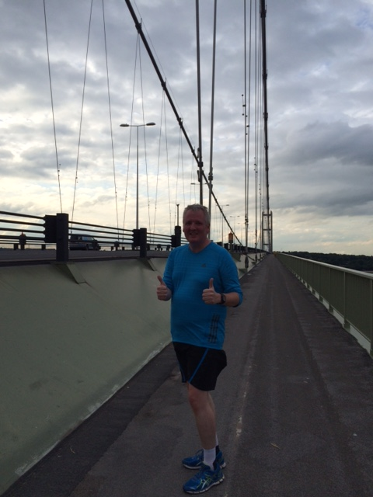
If you have not met all the backwards runners yet we will be the ones with a big a smile when running backwards as part of the normal warm up routine on Tuesdays and Saturdays and dare I say running backwards more quickly than anyone else! P.S. anyone for a sideways 5K run next year, oh no what have I done!!! ☺
Richard's 5km Anna's Miles for Mind challenge run!

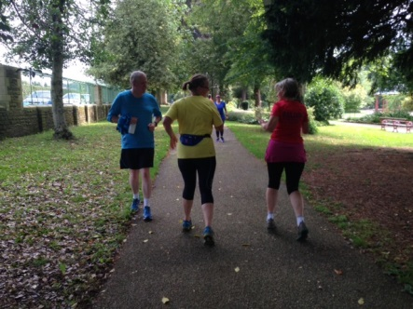  The route started in Roberts Park, continued along the river, then back on the canal for a few more laps round the park. | 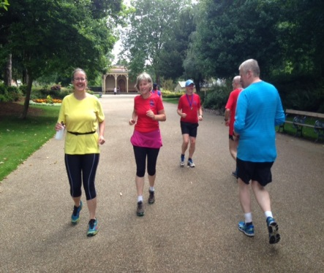  Can you tell who's running forwards and who's running backwards? | 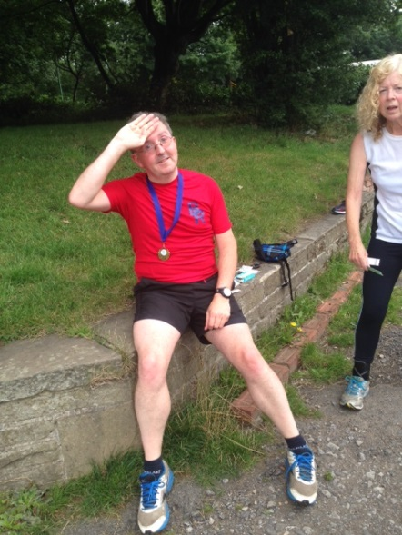  Sally to the rescue!
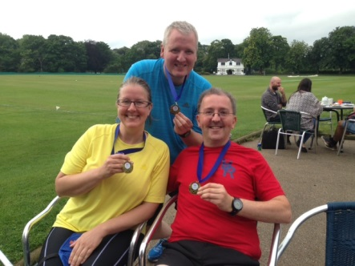  The 5km race medallists. | 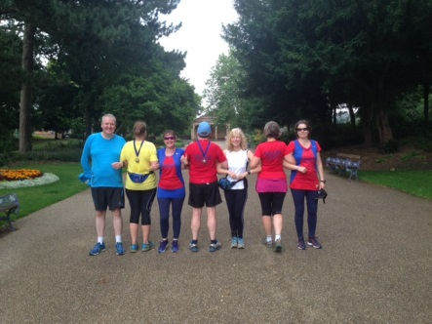  The backwards runners and their forwards facing support crew! | 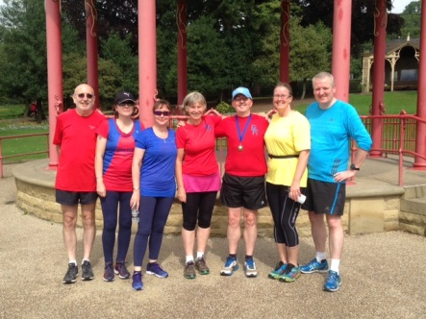  The team.

The Yorkshire Wineathon
by Philip Bland

Way back in the mists of time when some of us were enduring the training regime for a Spring Marathon (London in my case) a beacon of light appeared on the horizon in the form of the Yorkshire Wineathon. This was the perfect antidote to ploughing lonely multi mile furrows – a nice little 9 mile trail run in the lovely Kirklees countryside above Huddersfield starting at the pretty Thurstoneland Cricket Club and taking in the villages of Farnley Tyas, Brockholes and a brief perambulation around Castle Hill. The best bit though was that every two miles there would be not water stations but WINE stations !

My first thought was that Baildon Runners have some pretty good drinkers on the staff and that we could probably make a decent impression if we put out our A team. A short appeal on the Baildon Runners Facebook site brought an enthusiastic response (I nearly got killed in the rush!) and before we knew it we had a team of 18 fast drinkers to rival any other team.
Just a short perusal of the names should have made other entrants quake in their fancy dress – Sarah Terry, Karen Butler, Karen Baildon, Dave Lonsdale, Debbie Bland, Rob Myers, Rach Anmer, Jackie Walters and her daughter Susanna, Richard Depledge, Amanda Darbyshire, Jules Potter plus a supporting cast of friends. Did I mention that some of the braver souls were kitted up in fancy dress as the cast of Allo Allo complete with berets and baguettes!

Thankfully Sarah had the presence of mind to sort us out a team bus complete with some wine samples to get us in the mood (my sort of warm up!). Arriving at the cricket ground we were staggered to find over 800 like minded winos in fancy dress ready for the off! I must say it’s the first race I have ever started alongside people running with cans of Strongbow and camelbacks full of Sauvignon Blanc. The first wine station was upon us in no time (each wine station featured wines from different countries – this one was a cheeky little number from Sicily that took the enamel off your teeth!). The route was mainly off road along paths and trails and the odd ploughed field and whoever had measured it at nine miles must have got lost a few times – it was nearer eight !

After some rather tricky French stuff at wine station two it was a delight to arrive at the third, fully stocked with Aussie Red – a few of us spent quite a bit of time here savouring the grand Pennine views out towards Holme Moss. A grandstand finale with Spanish Rioja put us in the mood for a fast finish (downhill!). I have to say that some of us took the running side a bit too seriously and finished in 1:40 (ish) whilst those of us who took the wine tasting side to our hearts finished nearer 2:40 – and of course there were the burgers, bacon sarnies and the beer tent to provide some sustenance at the end.
Altogether a smashing day out and a good template for future Baildon Boundary Ways! A selection of frightening photos of the event are on the Baildon Runners Facebook site just in case you don’t believe us! The 2016 race is already open and we WILL be back. http://www.eventbrite.co.uk/e/wineathlon-yorkshire-2016-tickets-18507287796

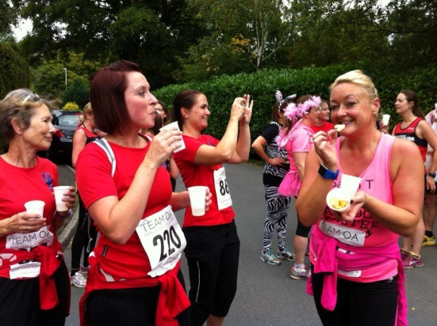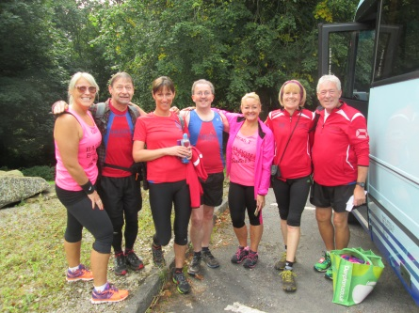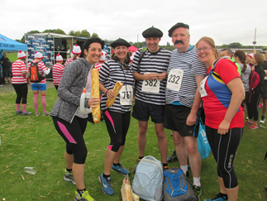

No Watch Night
Saltaire Striders were invited to join Baildon Runners for the annual “No Watch” night. Runners set off from the Rugby Club on a choice of a long or short route. They first recorded an estimated time to complete the route and undertook not to look at a watch during their run! The winners were those closest to their estimated time. Thanks to the excellent route directions provided by Alan Clements all but one runner went the right way, although the timing on the line experienced a few issues. The three clear winners however were John Hunt and Helen Love from Saltaire Striders and Baildon’s Jenny Stephenson. The evening concluded with a delicious spread thanks to Geraldine , Karen, Sue, Sarah and everyone else who prepared the food, in all a most enjoyable event.

AGE CATEGORY RECORDS
by John Cawley
Full details of all age category records can, as usual, be accessed on the club website, however the following is a list of the new records set since the last newsletter, including one from an earlier month that went ‘under the radar’:

Name | Cat | Distance | Date
Steve Pickard | M55 | Half Marathon | 21 June
Jim Wheldon | M60 | 5K | 29 August
Liz Caven | F45 | 20 miles | 6 September
Kirsty Allen | F40 | 10K | 6 September
Kirsty Allen | F40 | 10K | 27 September
Sue Coates | F65 | 10K | 27 September
Jim Wheldon | M60 | 10K | 27 September

RESULTS ROUNDUP September 2015
John Cawley

Please continue to email your race results to results@baildonrunners.co.uk but note there is no need to do this for parkrun events or summer championship races unless you are not shown in those results as a Baildon Runner, for example if you entered the race before joining the club. However, could second claim members please email all their results including parkruns.

For those of you who don’t want to wait for the next newsletter, all Baildon Runners’ parkrun results can be viewed shortly after the relevant Saturday at www.parkrun.com/results/consolidatedclub/?clubNum=1854.

Dulwich 5K parkrun - 29 August
127th | Sarah-Jane Templeman | 27:41 | 1st F45
155 finishers.

Greenwich 5K parkrun - 29 August
28th | Alice Buttle | 22:36 | 2nd F
143 finishers.

Halifax 5K parkrun - 29 August
60th | Amanda Darbyshire | 30:14
61st | Melanie West | 30:15
98 finishers.

Horton Park 5K parkrun - 29 August
10th | Debbie Bland | 24:01 | 1st F
12th | Philip Jones | 24:43 | 2nd M55
16th | Ian Hartman | 25:57 | 1st M65
45 finishers.

Lister Park 5K parkrun - 29 August
10th | Ben Watson | 19:46 | 3rd M35
13th | Kirsty Allen | 20:14 | 1st F
19th | Andrew Price | 21:05
26th | Danny Miles | 21:18
75th | John Cawley | 24:10
151st | Dave Shaw | 27:24 | 2nd M70
169th | Jonathan Hornby | 28:24
192nd | Richard Lund | 29:06
218th | Tara Philips | 30:08
260th | Shelagh Hopkinson | 31:30 | 2nd F60
323rd | Katie Greig | 34:18
324th | Fiona Grossick | 34:19
350th | Jenny Stephenson | 36:08
432 finishers.

Sewerby (Scarborough) 5K parkrun - 29 August
28th | Don Johnson | 22:41 | 1st M60
58th | Denise Johnson | 25:29 | 1st F55
158 finishers.

York 5K parkrun - 29 August
53rd | Jim Wheldon | 20:35 | 1st M60
409 finishers.

Leeds Golden Mile - 29 August
66th | Debbie Bland | 7:06 | 1st F60
79 finishers.

Ripon Trident Triathlon - 30 August

67th | Emma Stoney | 3rd F35
 | 1,500 metres swim | 30:17
 | Transition | 3:35
 | 40K bike | 1:16:52
 | Transition | 1:53
 | 10K run | 49:12
 | Total | 2:41:52
127 finishers.

Halifax Half Marathon - 30 August
28th | Mark Delaney | 1:47:03
125 finishers.

Tour of Norland Moor 6.2 miles, 800ft climb
30 August
17th | Jim Barnett | 44:56
58th | Rebecca Langdon | 56:18
60th | Rob Myers | 57:14
63rd | Ian Hartman | 58:50 | 2nd M65
79th | Kate Walter | 1:04:59
85th | Angela Pegg | 1:12:59 | 3rd F60
86th | Linda Carey | 1:13:07
87 finishers.

Reeth Show 2 miles, 800ft climb - 31 August
21st | Jim Barnett | 20:53
81 finishers.

Ilkley Incline 1 mile, 560ft climb - 2 September
48th | Jim Wheldon | 10:42 | 1st M60
55th | Neil Fairburn | 11:40
80 finishers.

Ultra Trail du Vercours (French Alps) 52.5 miles, 14,200ft climb - 5 September
93rd | Mick Cooper | 12:54:24
259th | Jacqueline Cooper | 16:17:18
292 finishers (56 DNF).

Cross Flatts 5K parkrun - 5 September
13th | Don Johnson | 21:52 | 1st M60
34th | Denise Johnson | 23:51 | 1st F55
133 finishers.

Horton Park 5K parkrun - 5 September
9th | Philip Jones | 24:08 | 1st M55
50th | Melanie West | 56:32 | 3rd F40
51st | Debbie Bland | 56:40 | 1st F60
53 finishers.

Lister Park 5K parkrun - 5 September
12th | Lee Kaznowski | 19:28
15th | Ben Watson | 20:15 | 3rd M35
26th | Andrew Price | 21:09
34th | John Buddle | 22:04 | 2nd M50
67th | Neil Fairburn | 23:46
209th | Sarah-Jane Templeman | 29:14
212th | Tara Philips | 29:21
227th | Dave Lonsdale | 29:45
382nd | Nicola Steffen | 38:44
431 finishers.

Leeds Country Way Relay - 6 September
Baildon Bison
Leg 1 | Paul Baildon & Paul Dennison | 1:22:42
Leg 2 | James Dickinson & David Long | 1:38:33
Leg 3 | Chris Longstaff & Jim Wheldon | 1:27:34
Leg 4 | Tony Deacon & Graham Driver | 1:48:37
Leg 5 | Jim Eyre & Jim Goddard | 2:19:44
Leg 6 | Alison Boyle & Emma Stoney | 1:18:39
28th out of 47 teams.

Baildon Buffalo
Leg 1 | John Cawley & Steve Tindall | 1:48:04
Leg 2 | Sue Coates & Carolyn Hargreaves | 2:58:54
Leg 3 | Sally Gavaghan & Jackie Walters | 1:52:38
Leg 4 | Linda Carey & Shelagh Hopkinson | 2:31:00
Leg 5 | Karen Baildon & Geoff Perigo | 1:36:41
Leg 6 | Kate Walter & Phil Bland | 1:57:51
47th out of 47 teams.

The following members took part in a composite Airedale Athletics team:
Leg 5 | Quentin Lewis & Michael Malyon | 1:03:21
The Airedale Athletics team finished 2nd.

Golden Ball 20 miles (Lancaster) - 6 September
48th | Liz Caven | 2:54:56 | 2nd F45
98 finishers.

Guisborough 3 Tops 8.1 miles, 2,149ft climb
6 September
228th | Philip Jones | 2:03:24
231st | Ian Hartman | 2:06:23
245 finishers.

Alice’s 10K (Mytholmroyd) - 6 September
8th | Phil E Brown | 41:34 | 1st M50
9th | Kirsty Allen | 41:51 | 1st F
188 finishers.

Tholthorpe 10K - 6 September
46th | Andrew Price | 42:36
113th | Gordon Slater | 48:08
340 finishers.

Nidderdale Sprint Triathlon - 12 September

35th | Emma Stoney
 | 400 metres swim | 8:18
 | Transition | 1:39
 | 20K bike | 43:41
 | Transition | 1:26
 | 5K run | 22:27
 | Total | 1:17:30
110th | Kate Walter
 | 400 metres swim | 12:44
 | Transition | 0:35
 | 20K bike | 51:50
 | Transition | 0:55
 | 5K run | 29:38
 | Total | 1:35:41
127 finishers.

World Masters Mountain Running Champs 5.5 miles, 1,500ft climb (Betws-y-Coed) - 12 September
M55+
38th | Philip Jones | 59:37
45 finishers.
M60
23rd | Jim Wheldon | 50:48
43 finishers.
Open race
14th | Ian Hartman | 1:07:01
17 finishers.

Horton Park 5K parkrun - 12 September
2nd | Ben Watson | 19:58 | 1st M35
13th | Don Johnson | 22:43 | 1st M60
42nd | Dave Shaw | 28:43 | 1st M70
48th | Amanda Darbyshire | 29:20 | 1st F35
100th | Melanie West | 54:15
102 finishers.

Yorkshireman Marathon 26.2 miles, 3,065ft climb - 13 September
59th | Andy Robinson | 4:48:55
134 finishers (6 DNF).

Yorkshireman ‘Half Marathon’ 14.8 miles, 1,750ft climb - 13 September
40th | Kirsty Allen | 2:06:36 | 2nd F40*
103rd | Alice Buttle | 2:28:03
107th | Nigel Shaw | 2:30:37
126th | Neil Fairburn | 2:35:42
156th | Rebecca Langdon | 2:44:42
176th | Debbie Bland | 2:55:22 | 1st F60
179th | Jim Goddard | 3:00:22
225th | Linda Carey | 3:25:14
* also third female overall
249 finishers (5 DNF).

Great North Run Half Marathon - 13 September
894th | Lee Kaznowski | 1:30:52
4,201st | John Cawley | 1:45:14
4,680th | Stephen Brown | 1:46:34
10,965th | Hester Stefanuti | 1:59:11
10,973rd | Jane Chapman | 1:59:12
10,974th | Abi Gallucci | 1:59:12
22,948th | Stephanie Jenner | 2:20:15
26,524th | Jonathan Hornby | 2:27:13
26,525th | Katherine Hornby | 2:27:13
35,228th | Judith Wilson | 2:51:04
40,880 finishers.

Rombald’s Romp 6.5 miles - 13 September
36th | Andrew Price | 59:24
86th | Steve Tindall | 1:13:31
114 finishers.

Spen Greenway 10K - 13 September
23rd | Ben Watson | 39:51
51st | Mark Delaney | 45:26
84th | Geoff Perigo | 52:03
111th | Sally Gavaghan | 57:52 | 1st F60
114th | Jackie Walters | 58.03
132nd | Geraldine Ray | 1:01:23
140th | Richard Depledge | 1:11:03
145th | Rachel Amner | 1:22:25
147 finishers.

Run the River 10K (London) - 15 September
1,582nd | Karen Butler | 1:03:36
1,936 finishers.

Siabod Summit Race (Capel Curig) 4.5K, 670m climb
16 September
Jim Wheldon | 44:27
Ian Hartman | 52:55
Positions/finishers unavailable.

Bramley 5K parkrun - 19 September
40th | Debbie Bland | 24:43 | 1st F60
158th | Phil Bland | 40:47 | 2nd M60
185 finishers.

Fountains Abbey 5K parkrun - 19 September
89th | Steve Tindall | 25:35
251 finishers.

Horton Park 5K parkrun - 19 September
6th | Jim Barnett | 21:44 | 3rd MU35
8th | Don Johnson | 22:19 | 1st M60
33rd | Amanda Darbyshire | 29:10 | 1st F35*
57th | Melanie West | 52:31
* also third female overall
57 finishers.

Lincoln 5K parkrun - 19 September
57th | Mick Cooper | 22:54
265 finishers.

Lister Park 5K parkrun - 19 September
11th | Ben Watson | 20:19 | 3rd M35
51st | Neil Fairburn | 23:05
55th | John Buddle | 23:19
332nd | Nicola Steffen | 36:37
395 finishers.

Vale of York Half Marathon - 20 September
225th | Graham Driver | 1:35:13
1,218 finishers.

Beefy’s Nab 3 miles, 650ft climb - 20 September
7th | Jim Barnett | 27:14
13th | Neil Fairburn | 28:34 | 3rd M50
20th | Rebecca Langdon | 31:43 | 1st F35
28th | Ian Hartman | 33:29 | 2nd M65
32 finishers.

Fell Foot (Newby Bridge) 5K parkrun - 26 September
74th | Jacqueline Cooper | 26:49
75th | Mick Cooper | 26:49
144 finishers.

Goole 5K parkrun - 26 September
45th | Denise Johnson | 29:36 | 1st M55
46th | Don Johnson | 29:37 | 2nd M60
69 finishers.

Horton Park 5K parkrun - 26 September
12th | Philip Jones | 24:10 | 2nd M55
26th | Amanda Darbyshire | 28:19 | 1st F35
49th | Melanie West | 52:43
57 finishers.

Lister Park 5K parkrun - 26 September
6th | Lee Kaznowski | 19:38 | 1st MU35
20th | John Buddle | 21:46 | 2nd M50
81st | Michelle Morris | 25:08
106th | Steve Tindall | 26:28
124th | Graham Driver | 27:29
214th | Shelagh Hopkinson | 31:37 | 2nd F60
218th | Sarah-Jane Templeman | 31:52
219th | Tara Philips | 31:54
246th | Elinor Newhouse | 33:23 | 3rd F65
266th | Leanne West | 35:13
331st | Jenny Stephenson | 46:47
340 finishers.

Brownlee Sprint Triathlon - 26 September

490th | Karen Butler
 | 400 metres swim | 16:07
 | Transition | 3:18
 | 20K bike | 1:08:11
 | Transition | 1:16
 | 5K run | 37:23
 | Total | 2:06:15
497th | Sarah Terry
 | 400 metres swim | 16:43
 | Transition | 3:17
 | 20K bike | 1:08:42
 | Transition | 1:44
 | 5K run | 36:22
 | Total | 2:06:43
730 finishers.

Berlin Marathon - 27 September
25,377th | Dan Cobb | 5:01:55
36,817 finishers.

Kirkstall Abbey 7 miles - 27 September
153rd | Debbie Bland | 54:03 | 1st F60
287th | Dave Lonsdale | 1:06:15
300th | Linda Carey | 1:08:12
333rd | Phil Bland | 1:12:24
361 finishers.

Great Yorkshire 10K (Sheffield) - 27 September
1,733rd | Joanne Bloor | 1:00:51
2,952 finishers.

A special mention for Joanne Bloor’s daughter Ffion who ran the Great Yorkshire 1.5K junior run in 7:28.

Bradford 10K - 27 September
22nd | Michael Malyon | 36:11
39th | Lee Kaznowski | 38:39
48th | Kirsty Allen | 39:13 | 2nd F40*
53rd | Ben Watson | 39:33
56th | Paul Baildon | 39:53
76th | Mark Delaney | 41:29
94th | Jim Wheldon | 42:35
109th | Nigel Shaw | 43:20
140th | David Long | 44:34
200th | Philip Jones | 48:05
239th | Col Morley | 49:18
243rd | Jim Goddard | 49:28
294th | Karen Baildon | 51:39
305th | John Colwell | 52:06
363rd | Sue Coates | 54:44 | 3rd F65
404th | Sally Gavaghan | 56:08
407th | Jane Clough | 56:14
408th | Emma Long | 56:14
415th | Jackie Walters | 56:26
492nd | Geraldine Ray | 59:15
519th | Jenny Colwell | 1:01:06
629th | Richard Depledge | 1:09:24
656th | Susanna Walters | 1:15:26
658th | Rachel Amner | 1:15:55
* also third female overall
683 finishers.

SUMMER CHAMPIONSHIP

These are the remaining races in the Club’s Summer Championship 2015.

Race No Name Distance Time Day Date

Race 18 Bradford Parkrun 5K 9.00 am Saturday 17 October 2015
Race 19 Bradford Half Marathon 9.40 am Sunday 25 October 2015
Race 20 Wistow (Selby) 10K 11.00 am Sunday 25 October 2015

FORTHCOMING RACES
Where there is not a hyperlink or email address, this is usually because the entry form is not yet available.
Every Saturday morning at 9:00 | Lister Park 5K parkrun (Bradford), Hyde Park 5K parkrun (Leeds),  Horton Park 5k parkrun (Bradford)  Roundhay Park 5K parkrun (Leeds), Temple Newsam 5K parkrun (Leeds), Cross Flatts Park 5K parkrun  Free events, must pre-register online by 6:00pm Friday, and take the barcode emailed to you.

4 October | Burnley Fire 10K
4 October | Cusworth 10K
10 October | Yorkshire Vets Championship Relays, Roberts Park
17 October | Bradford Parkrun (SC)
11 October | Yorkshire Marathon (York) ENTRIES CLOSED
11 October | Withins Skyline 12K, 300m ascent (Penistone Hill Country Park, nr Haworth)
20 September | Lancaster Half Marathon
25 October | Bradford Half Marathon (SC event)
24 October | Pain Barrier 10K (Tong)
8 November | Wadsworth Half Trog 9.25 miles (Hebden Bridge)
15 November | Leeds Abbey Dash 10K
6 December | Guy’s 10 miles (Garstang)
20 December | Stoop 8K, 250m ascent (Penistone Hill Country Park, nr Haworth)
31 December | Auld Lang Syne 9.6K, 300m ascent (Penistone Hill Country Park, nr Haworth)

COMMITTEE MEMBERS
Ian Ferris Secretary, Club Coach, Beginners, Run England and BAN Rep
Paul Baildon Treasurer
Dave Lonsdale Membership Secretary and Curry Nights
Kevin Brain Quarterly Magazine
Sue Coates Carnival Canter and Kit
Dan Cobb Announcements and WYWL Rep
Matthew Gurney Development Group Link and AA Link
Gareth Holme Men’s Relay Team Captain
Geoff Perigo Webmaster, Club Diary and Routes
Lizzie Smith Minutes
Geraldine Ray Social Secretary
Emma Stoney Ladies’ Relay Team Captain
Jeremy Smith Summer Championship
Jackie Walters Newsletter Editor, Leaders for D,E and Sunday runs

OTHER CONTACTS WEBSITE AND EMAIL ADDRESSES
Catherine Milner Club Auditor Website: baildonrunners.co.uk
Richard Barnes Garmin Routes General Email: baildonrunners@yahoo.co.uk
John Cawley Club Records and Results Newsletter email: news@baildonrunners.co.uk
Alan Clements Joint Club Liaison Results email: results@baildonrunners.co.uk
Denise Johnson Veterans
Anna Smith Off-Road Leagues
Emma Stoney Baildon Boundary Way Director

