## FROM THE EDITOR

**by Lizzie Rhodes**

Following feedback received from Members, this edition of the Newsletter includes a roundup of the races that have taken place in May and June. Individual results will still appear on the website.

If you have any feedback, please let me know by emailing [news@baildonrunners.co.uk](mailto:news@baildonrunners.co.uk) and I will do my best to incorporate into a future Newsletter.

Thanks

*Bingley Away Night*

*Bingley Away Night*

## CONTRIBUTIONS TO THE NEWSLETTER

**by Lizzie Rhodes**

This newsletter has been brought to you by Phil Bland, Alan Clements, Sue Coates, Michelle Morris, Geoff Perigo, Geraldine Ray and Lizzie Rhodes. Thanks for your contributions.

Do you have an item that may be of interest to your fellow Members? You don’t need to worry about style, spelling or grammar, I will edit/amend if necessary.

Please send your contributions to [news@baildonrunners.co.uk](mailto:news@baildonrunners.co.uk) **no later than Monday 4 August 2014**.

Thanks.

## NEW MEMBERS

We have two new members to report this month, Sarah Cheshire and Rebecca Powell. A warm welcome to you both!

**PROFILES OF COMMITTEE MEMBERS**

Over the next few months the Newsletter will feature profiles of your Committee Members so you know who to turn to should you have a query.

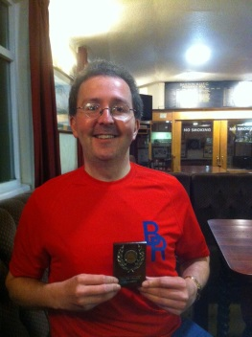

**Name:** Dave Lonsdale

**Role on the Committee:** Treasurer and Membership Secretary

**Job:** Gatekeeper for the financial well being of the Club, managing receipts/payments and producing the Year End and BBWay accounts for the AGM. Tutting and making sharp intakes of breath when the Committee think about spending money (‘you don’t need a new clock Sue’), reminding / nagging members to pay their subs, to pay for Club kit, to pay for the Christmas Party ☺. Welcoming new members and registering members with

England Athletics. Occasional Thursday and Sunday Run Leader. Monthly curry night organiser and participant, in my ‘spare time’ away from the Club I am an IT Manager. ☺

**When did you start running?** In 2006 to keep my friend company as she wanted to join her local club (Baildon Runners) but didn’t want to be on her own as a newbie. I hated cross country running at school but was made very welcome by the Club and especially by Sue and Debra in my early beginner days of ‘huffing and puffing’, hence my 5 years and counting on the Committee.

**Length of time at the Club:** 8 years and counting…loving it!

**Why do you run?** Fitness benefits, sense of achievement, being in the great outdoors and spending quality time with great people.

**Least favourite aspect of running?**  Injuries, our Club Coach’s dodgy watch (the 1 minute to go warning does last longer than a minute!) and my own lack of direction (running 10.5 miles recceing GWF relay route and only covering the first 3 miles of the actual 9 mile route!)

**First Race:** Cancer Research UK 10k race at Castle Howard

**Favourite race(s):** Full Bronte 5 and Great Trail Challenge at Keswick

**Greatest Running Feat:** I am greedy so I’ll list three: Club record holder at 25K (as no one else has run the distance in Club colours and please keep it that way!), Summer Championship Division 2 Winner in 2012 (my first and possibly last trophy for winning a running competition) and completing the London Marathon in 2011 (despite damaging my left calf after only 4 miles).

**Other Sports / hobbies:** Leeds Rhinos, Socialising, Listening to Music, Travel, Online Scrabble.

**Super power you would most like to have?** To have enough time to do everything I want to, to improve my running without having to commit the time to do so and the ability to remember to bring a change of socks/shoes when boggy running conditions are likely. ☺

**Tell us something interesting about yourself**: I was a season ticket holder with Leeds United and had some amazing experiences travelling across Europe with the team and the fan,s especially in Moscow (two trips in three weeks), drinking proper vodka and smuggling a Russian sports journalist into the away end ….. these two events may be linked. ☺

**RUNNER OF THE MONTH**



Runner of the Month for May was Michelle Morris for completing the City to Summit race in Scotland (see article below). Michelle’s prize was a bottle of wine.

WELL DONE!!

**MY CITY TO SUMMIT ADVENTURE**

**by Michelle Morris**

On the 31st May 2014 I raced City to Summit in Scotland. This involved a 2.4 mile swim in the Firth of Forth, followed by a 112 mile road cycle to Glencoe. Then the trail shoes are on for a 27 mile run, most of which was off road, with the added fun of an assent and decent of Ben Nevis to finish! It was a fantastic race and I loved it ☺.

Training started properly on the 1st January (after 3 weeks in Thailand) and it was a hard, painful start. I struggled with the winter league races. I struggled with Thursday runs. It was all hard, but I stuck with it. Mostly I found I was slow, but could keep going at that pace for a long time (this gave me confidence)! I have been away for hen dos, weddings and lots of social engagements. With me travelled the running shoes or the bike! I have trained on the 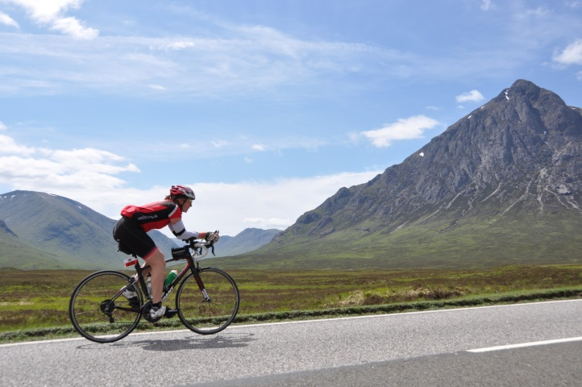Hereford fells, in the mud near Bath in between murder mystery and wine tasting (while the other hens fitted in pampering and bucks fizz breakfasts)! I have ridden my bike around Wiltshire, getting back in time to be at the church before the Bride! And then got up the next morning to see the sights of Stonehenge and the Old Sarum, with only a brief pause on the bike for a photo stop! I have cycled the cobbles of the Arenburg trench as part of the Paris Roubaix spring classic. I donned the head torch and ran on the moors throughout dark wet winter evenings! Supported by friends and my boyfriend for most of the training, but there have been some solitary runs and rides against the elements which involved a battle with the mind too! I ran the three peaks again (in a very tired state following my biggest training weeks) and whilst slower than last year, I finished in much better shape, ironing out problems with nutrition/hydration which caused bad cramp the year before. I started May absolutely shattered and desperate to start to taper! By the time City to Summit arrived I felt the best I’d felt in ages! But with no idea how fast I might be! I was confident I would meet the cut offs for the race (but who knew for sure!).

I registered the day before the event and racked my bike in transition ready for the 6am start. The big question was – would the swim be full distance. The British Triathlon Federation (BTF) rules state that if the water is below 12 degrees centigrade only 1000m can be swum. However, City to Summit was not run under BTF rules, but surely they would not risk hyperthermia of 300 competitors making them do the full distance? Race briefing was at 5.45am. The news is the full distance would be swum, despite it being below 11.5 degrees! Eek!

The Sun was shining – the water was still. The bridges made for a really iconic setting! Wetsuited, with a neoprene hat under the race hat, along with neoprene boots and gloves I was ready! At 6am the race started.

I was swimming well. It was a two lap course, I felt certain I could swim a negative split after a steady first lap – however – not to be! The current dragged the marker buoy out so I battled for an extra ten minutes on lap 2! But finished the swim in 1h25. 8 minutes in transition for a full change (I wanted to be dry and comfortable for the cycle). On the bike I am at my best. Just under 7 hours including the 3 pit stops for food - supplied to me by my boyfriend, James. I arrived in Glencoe. 10 minutes in transition for another full change and this time jam sandwiches and a cup of tea. I also had an ice pack for my feet after a spot of hot foot from the bike. It was 20 degrees and really sunny! A head wind for the last 10 miles on the bike was pretty relentless, especially as this was a downhill section!

Onto the run. This involved carrying all the usual required kit for a fell race (full body waterproofs, whistle, hat gloves, food, water), plus an extra thermal layer, a first aid kit, survival blanket and head torch. The first 6 miles were on the road around a loch which was very pretty and undulating. At 6 miles it was off road for a 400m assent! This was tough! But the views from the top were spectacular! I managed to pick off a few men who were melting in the heat. Once at the top it was like running down a rabbit track through a dry river bed for the next few miles – I loved this bit! Then a river crossing and onto the West highland way for a few more undulating miles over rough terrain. Eventually at 19 miles in I reach Glen Nevis for the run pit stop. It had all gone well until a couple of miles before when I ran out of water, but all in all I was in good shape. I sat down for about 20 minutes and ate more jam and peanut butter sandwiches, crisps, breakfast bars and tea. A nice change from the energy gels and bars and nuun I’d been consuming on the move.

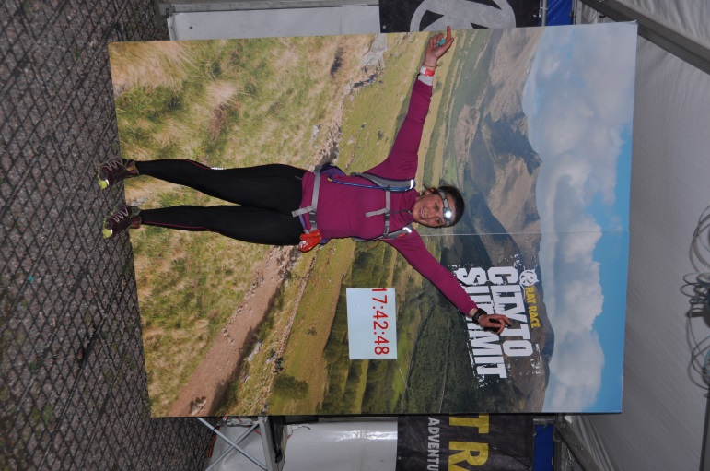After a grilling from the marshals (checking I was still ‘with it’ I suppose) I continued – just as an LBT team mate, Joe Mellor, arrived at the Pit Stop. Now there was about 1km of descent before I started the stair case which was the Ben. The route went up the tourist track, starting from the little foot bridge by the Youth hostel. It was here that my race (!) slowed right down. I passed some people. I was passed by people, including Joe. On and on it went (9km according to my Garmin). Runners were passing me on their descent! The first lady came back past me when I was still a mile from the top! There was plenty of snow up there too. I was in a group now and there was good banter – as you know I’m only happy when I have someone to chatter to! I ran across the snow at the top and up the steps to dib in - which was on top of the trig point! – It really was a race to the summit!).

Now for the decent – could I get down before dark! It was so rough scrambling over all the rocks – I took the descent slow – I had come so far I needed to get home in one piece. There was a steady stream of people still on their way up the mountain! Just over half way down, the head torch was needed. It really was exciting now descending in the pitch black! Eventually I crossed the finish line to a buzzing finish area! It felt incredible! I was so happy to finish! In total I took 17h 42 min and finished 4th lady (out of 8 who finished from 12 who started)!

**EVEN AULDER JOGGER’S BLOG!**

**By Phil Bland**

Regular readers will wonder what has happened to Colin who usually writes so eloquently on this page – well, I’ve been warning folk for years that running is bad for you and sure enough he has gone down with something I can’t even spell. Get well soon Colin – you’re a hard act to follow !

Whilst raking through the various running disasters that have befallen me during the last month I couldn’t help but feel a pang of sympathy for Andy Murray. As defending Division 2 Champion and Most Improved Runner of the Year last year (how on earth did I do that !) the pressure has been telling. Those of you who know my good lady (a.k.a. The Boss) will realise that I have been gently “encouraged” to try harder – she is an enthusiastic follower of the North Korean training manual !

So it came to pass that I found myself on the start line of the Calderdale Way Relay decked out in Club colours, weight of expectations heavy on my shoulders and my new running partner – The Boss. I had been sold this gig on the basis that it was the shortest leg on offer and that it would all be over very quickly – they lied ! The recce revealed that you need crampons and Oxygen on this leg not to mention the nimbleness of a mountain goat and lungs like a hot air balloon.

We survived – we weren’t last and we got home before dark. Sadly this only encouraged “The Boss” and before long I found myself involved in assorted Club relays, Grand Prix etc culminating in – horror of horrors – Leg 5 of the Bradford Millennium Way Relay (nicknamed the “Marquis de Sade leg) again running with “The Boss”. We evolved a tactic of me getting cracking over the rough stuff and The Boss catching me up on the smoother sections – and it worked. We overtook two teams (to their amazement !) and actually finished together with a victory roll in Bingley – only to discover later that our valiant efforts had been messed up by the timekeepers (I don’t think they will do that again after an Excocet email from the Boss !)

So thank you Baildon Runners for introducing me to this wonderful world of pain and especially to The Boss for her endless encouragement (aren’t cattle prods illegal ?) – Colin, I want to know where you get this plantar…..whatever it’s called….stuff from !

**THERE MUST BE EASIER WAYS TO GET A T-SHIRT**

**by Geraldine Ray**

**C:\Users\Lizzie\AppData\Local\Microsoft\Windows\Temporary Internet Files\Content.IE5\7S898BSS\MC900013595[1].wmf**Only 35 more to go to my 50 park runs...there must be easier ways to get a T-shirt!  
  
**The start**  
7.30am my alarm is set  
Saturday morn out of bed I get  
I arrive at the park in rain or sun  
The runners swarm and get ready to run  
My watch is set, the nerves kick in  
The starter shouts and we begin.

**Lap 1**  
I'm full of beans, up the hill we start  
Past the hall, no time for art  
Down hill at last I'm feeling good  
I'm trying hard, I know I should

**Lap 2**  
I pass the bandstand and the hall  
Come on legs, once more that's all!  
Up the Teeny Tiny Hill I go  
Keep going, don't stop, we're "Awesome" you know  
  
  
**The Results**  
I check my email, results are there  
Wow a PB, 12 seconds to spare!  
I feel so proud I almost can't speak   
I've forgotten the pain, I'll be back next week!

**Lap 3**  
Once more around, I'm almost done  
Remind me, is this really fun?  
I reach the hill, I'm feeling weak  
My legs in pain, can't breath, can't speak  
I hear a voice "come on, you can do it"  
I manage a sprint, there's nothing to it!?

**SUMMER AWAY NIGHTS**

***By Geoff Perigo***

Please see below a list of away nights where we do not start out from the Club.

**July**

24th      Old Glen House to run reverse leg 3 of GWF relay

**August**

7th         Otley Chevin

**THURSDAY NIGHT RUNNING GROUPS**

**by Sue Coates**

Below is a list of the volunteers to lead the Thursday night groups D and E:

**Date Group D Group E**

17/07/14 Richard Barnes Sally Gavaghan

24/07/14 Geoff Perigo Sue Coates

31/07/14 Carolyn Hargreaves John Cawley

I realise it is holiday time, if any of the above dates are not convenient to you and you can’t get in touch with someone to swap with, just let me know and I will sort it out, it won’t be a problem.

## SUNDAY SESSIONS

by Lizzie Rhodes

Due to the Summer Championships there will a limited number of led Sunday sessions over the next couple of months. Please see the rota below.

**Date Leader**

20 July 2014 Harrogate 10K

27 July 2014 Dan Cobb

3 August 2014 Carolyn Hargreaves

10 August 2014 Askern 10 Miles / Birkenshaw 5 Miles

17 August 2014 Dave Lonsdale

## SUMMER CHAMPIONSHIP

**by Alan Clements**

C:\Users\Lizzie\AppData\Local\Microsoft\Windows\Temporary Internet Files\Content.IE5\CPW1V9YQ\MM900336560[1].gif

The Summer Championship has almost reached the half way stage, both in time and number of events, with 9 of the scheduled 20 events having taken place. With your best six results counting, there is still time to get yourself into the competition.

The outstanding performance so far, has come in the Second Division, with Sally Gavaghan having scored maximum 180 points in the five events she has entered. One more repeat and she will be guaranteed a share of not only the Second Division title, but also the overall shield. Behind Sally, Sarah Terry, Joanne Bloor and Karen Baildon are all closely grouped.

In the First Division, Liz Caven has competed in six races and scored 179 points. She is closely followed by Nigel Shaw and Neil Fairburn, who have both completed five races.

The Premier Division shows Paul Baildon in the lead, having dropped only 10 points in the five races he has completed. Debbie Bland and Barbara Lee have also completed five races each and are not far behind Paul.

The full tables can be found on the website and have also been posted in the Rugby clubhouse and changing rooms.

My apologies to those people whose results have been shown incorrectly. I have been made aware that there are still some errors in there and will correct them, when the Eccup 10 results are being posted. If you feel that any of your results seem to be incorrect, please contact me and I will investigate.

## SUMMER CHAMPIONSHIP RACES 2014

The remaining races in the Summer Championship are as follows:

**Date Event Distance** **Date Event Distance**

20 July [Harrogate](http://www.ukresults.net/forms/140720harrogate.pdf) 10K 21 September [Warrington](http://www.q-buster.co.uk/index.php?rn=667&action=show_detail) ½ Marathon

2 August [Bradford Parkrun](http://www.parkrun.org.uk/bradford/) 5K 28 September Horsforth 10K

10 August Askern 10 miles 26 October Wistow (Selby) 10K

10 August Birkenshaw 5 miles 26 October Bradford ½ Marathon

14 September [Spen Greenway](http://bookitzone.com/chris_drake/9B2FFX) 10K ? October [Bradford Parkrun](http://www.parkrun.org.uk/bradford/) 5K

## SPORTSSHOES.COM CONCESSION

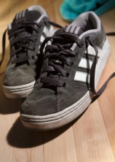Sportsshoes.com are keen to continue their relationship with the Club following the closure of their Bradford superstore. They are offering a concession to members purchasing online or by phone by way of a promotional code that you will need to key in at the checkout stage or quote over the phone. The code to use throughout July is (members only) and entitles you to 10% off and free standard P&P. A new code will be supplied for August. This will ensure it stays exclusive to our Club members.

Please note that the reduction does not show on the pricing screen nor the order confirmation and that sportsshoes.com request credit card authorisation for the full amount. What happens is that the reduction is applied manually after they take the order and hence you should be getting the reduced price.

## AGE CATEGORY RECORDS

This information will now be accessed through the website at [www.baildonrunners.co.uk](http://www.baildonrunners.co.uk)

## RESULTS ROUNDUP

**by Phil Bland**

## MAY

May began with the **John Carr Race series** at Esholt, part of our Summer Championships series and 29 Baildon Runners took part in all three races in the series with some super performances – cumulatively **Quentin Lewis** topped our men’s performances with 48:09 across the three races with **Liz Caven** our top lady (65:37). There were also numerous YVAA prize winners – Quentin again with 2nd MV35, **Barbara Lee & Carolyn Hargreaves** (2nd & 3rd LV55) and **Debbie Bland** (1st LV60**) Jackie Walters** won 1st FV65 in Race 1 (27:29)

Hot on the heels of the John Carrs came the gruelling Calderdale Way Relays where **Baildon A** finished a very creditable 27th (7hrs 37m) and **Baildon B** 75th in 10hrs 05:10s. The race was won by Calder Valley in a staggering

5hrs:57:12 ! Congrats to **Gareth Holme and Emma Stoney** who set a new Club record for the very steep Stage 3 (I know its steep because I ran it !)

A highlight of our May running was the local **Over the Odda 10k** trail race featuring our very own Emma Stoney as Race Director. Everyone agreed the race was a spectacular success – 27 Baildon Runners showed up to run and we raided the prizes big style – 1st FV45 **Liz Caven**, 1st MV55 **Paul Dennison**, 1st MV60 **Ian Hartman,** 1st FV60 **Debbie Bland** and 1st FV65 **Sue Coates**.Emma pulled off a coup for Baildon Runners by recruiting to the Club the ladies winner, Rebecca Powell (who just happens to be her sister !). Welcome Rebecca.

The month was rounded off in fine style with the **Ilkley Trail Race** – a scenic tour of the moors above Middleton with a steep start on Curly Hill. Seven Baildon Runners made the trip with **Phil Brown** emerging as our fastest finisher in 54:56. As usual, Tom Adams smashed his own course record to finish in 38:52 !

**JUNE**

A very busy racing month for our runners with no less than three Summer Championship races and two major relays to cope with.

Early in the month **Debbie Bland** showed the Lancastrians what Baildon Runners are made of by taking out the 1st FV60 prize at **the Wigan 10k Trail Race** (the highlight of which was free Pie & Peas to all finishers !)

4th June saw three of our hardy (should that read “foolhardy” !) blokes take on the **Chevin Fell Race,** a full on blast up Otley Chevin from the town centre & back. Congrats to **Neil Fairbairn** (25:52), **Andy Price** (26:08) & **Jim Goddard** (27:59). Matt John (Otley AC) won in a lung busting 18:15.

The very next day saw the **Full Bronte 5 mile,** a tough little two lap race out of Haworth. Summer Championship status saw a good turnout of 17 Baildon Runners with **Paul Baildon** top dog in 33:06 and a thrilling photo finish between **Liz Caven** and **Debbie Bland**, with **Debbie** just edging it by a second in 38:26 to take the 5 mile FV60 Club record off **Sue Coates** (sorry Sue !). **Liz** won 1st FV45.

The Tour de France is the big thing at the moment and **Debbie** went on to run a new Halifax Harriers race **“Le Two r Halves”** which tackles the longest continuous ascent in England of 5.5 miles out of Mytholmroyd and back – part of this year’s TdF route. With **Phil Jones** for company **Debbie** ran well to bag 3rd Lady overall in 1:21:47.

Meanwhile, encouraged by our successful raids across the Pennines, **Don & Denise Johnson** ran the **Blue Light 5 Mile** Road race at Blackpool to good effect with **Don** rediscovering his best racing form to post a new MV60 5 Mile Club Record of 36:18 whilst **Denise**, coming back from recent injury, ran 41:31

Summer Championship races continued with the **Otley 10** – another toughie ! Just nine Baildon Runners for this one with **Ben Watson** our first man home in a very creditable 1:12:47. **Liz Caven** took 4th FV45 in 1:22:14 and **Debbie Bland** 2nd FV60 in 1:20:52

Next up in this busy month was the **Yorkshire Vets Championship Relays** held in Roberts Park, Saltaire. Fiercely contested by some of the best teams in Yorkshire, Baildon Runners fielded several teams who all ran well to finish with **2nd MV35 Team** and **2nd FV55 Team** prizes - **Quentin Lewis** running the fastest leg (14:41) on the day.

Our next Summer Championship race – the **Freckleton Half Marathon** – saw a solitary Baildon Runner make the journey over to the “dark side” – congrats to **Richard Sykes** who flew the flag in 2:29:01

In a busy last week of the month **Rebecca Langdon, Debbie Bland** and your correspondent ran the **YVAA Grand Prix race at Alwoodley** – a two lap mixed terrain race, with varied success – **Rebecca** was a faller early on (thankfully no harm done), my 52:13 barely rates a mention but **Debbie** saved the day with another 1st FV60 prize in 43:05

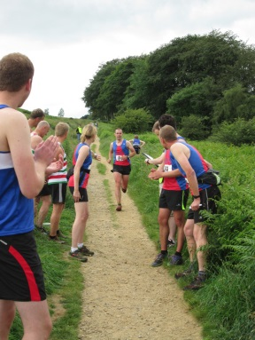Finally, the big one – **The Bradford Millennium Way Relay** – with 43 teams racing in pairs across five legs of tough cross country terrain with some steep climbing. We had two teams in the mix, **Baildon A** finishing in a cumulative time of 7hrs 18m 09s (15th) and **Baildon B** – 9hrs 08m 55s (40th). Two Club records were set - **Sue Coates & Helen Foster** (Ladies Leg 3) & **Chris Longstaffe and Ben Watson** (Male Leg 4). Wharfedale won the event in an amazing 5hrs 34m 17s.

And Finally finally ! We must mention **Bradford parkrun**. During June we notched up no less than 12 PBs with five alone set on the 28th June. Special mention to **Ben Watson** who was 10th in the race & PB’d at 20:05 and **Elinor Newhouse** who has set no less than five consecutive PBs bringing her time down from 32:01 to 31:21 in just five weeks. Pretty impressive !

Please let us know of your racing results and get your name up in lights (especially if racing further afield) by emailing them to the results email on the website homepage. Results will be picked up from the Championship races. However, if you have taken part in any other races you would like to be recorded or you notice any anomalies, please email [results@baildonrunners.co.uk](mailto:results@baildonrunners.co.uk).

## 

## QUOTE OF THE MONTH

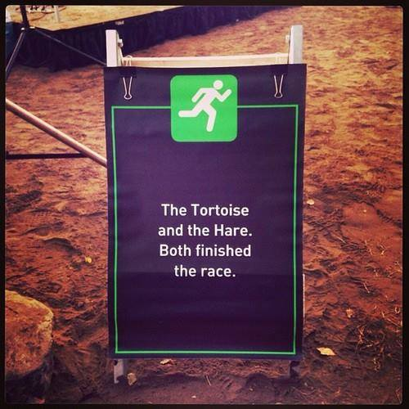

## FORTHCOMING RACES

Mostly there is a hyperlink to a website or email address but where there isn’t, this is usually because the entry form is not yet available.

Every Saturday [Lister Park 5K parkrun](http://www.parkrun.org.uk/bradford/home) (Bradford), [Hyde Park 5K parkrun](http://www.parkrun.org.uk/leeds/home) (Leeds), [Roundhay Park 5K morning at 9:00 parkrun](http://www.parkrun.org.uk/roundhay/home) (Leeds), [Temple Newsam 5K parkrun](http://www.parkrun.org.uk/templenewsam/) (Leeds), [Cross Flatts Park 5K parkrun](http://www.parkrun.org.uk/crossflatts) (Beeston, Leeds)  
 All are free events, but you must pre‑register online by 6:00pm Friday, and take the barcode emailed to you.

Every Sunday [Otley Chevin Forest Park 3 miles](http://www.runsunday.com/)  
morning at 10:30 Free event, but you must pre‑register and take the barcode emailed to you.

20 July [Harrogate 10K](http://www.ukresults.net/forms/140720harrogate.pdf) (SC event) 23 August [Burnsall 10 miles](http://burnsallsports.co.uk/)

20 July [Jane Tomlinson’s Leeds 10K](http://www.forallevents.co.uk/run-for-all/events/10k/leeds-10k/) 23 August [Honley 10K](http://www.addicted2running.co.uk/Scripts/Honley%2010k.html) (nr. Holmfirth)

20 July [Saltaire Shaker 15K](http://www.saltaireshaker.com:80/enter-saltaire-shaker.php) 24 August [Fleetwood Half Marathon](http://www.fyldecoastrunning.org/index.php?route=product/product&path=59&product_id=60)

27 July [James Herriot Country Trail 14K](http://www.ukresults.net/forms/140727herriot.doc) 24 August [Escrick 10K](http://www.ukresults.net/forms/140824escrick.pdf) (nr. York)

(Wensleydale) 31 August Leeds Country Way Relay

3 August [Wagon & Horses 10 miles](http://www.ukroadraces.info/entryforms/2014/lans.doc) (Lancaster) 31 August [Blackpool Hilton Half Marathon](http://www.fyldecoastrunning.org/index.php?route=product/product&path=59&product_id=61)

10 August Askern 10 miles (SC event) 31 August [Blackpool Hilton Half Marathon](http://www.fyldecoastrunning.org/index.php?route=product/product&path=59&product_id=61)

17 August [Wagon & Horses Half Marathon](http://ukroadraces.info/entryforms/2014/lanhs.doc) (Lancaster) 31 August [Wetherby 10K](http://www.ukresults.net/forms/140831wetherby.pdf)

## COMMITTEE MEMBERS

|  |  |
| --- | --- |
| Alan Clements | Secretary, Joint Club Liaison and BBWay Race Director |
| Dave Lonsdale | Treasurer, Membership Secretary & Curry Nights |
| Kevin Brain | To be announced |
| Sue Coates | Social Secretary, Carnival Canter & Kit |
| Dan Cobb | Announcements & WYWL rep |
| Ian Ferris | Club Coach, Beginners, Run England & BAN Rep |
| Matthew Gurney | Development Group Link, AA Link and BBWay Entries Secretary |
| Gareth Holme | Men’s Relay Team Captain |
| Geoff Perigo | Webmaster, Club diary & routes |
| Lizzie Rhodes | Minutes and Newsletter |
| Tracy Robinson | Assistant Social Secretary |
| Emma Stoney | Ladies’ Relay Team Captain |

## OTHER CONTACTS

|  |  |
| --- | --- |
| Paul Baildon | Club Auditor |
| Richard Barnes | Garmin routes |
| Liz Boothman | Schools Liaison |
| Chris Burke | BBWay Course Marshall |
| Colin Davidson | T & A reports |
| Hamid Houman | BBWay Course Director |
| Denise Johnson | Veterans |
| Michelle Morris | BBWay Chief Marshal |
| Anna Smith | Off‑Road Leagues |

## WEBSITE AND EMAIL ADDRESSES

|  |  |
| --- | --- |
| Website: | [baildonrunners.co.uk](http://baildonrunners.co.uk/) |
| General email: | [baildonrunners@yahoo.co.uk](mailto:baildonrunners@yahoo.co.uk) |
| Newsletter email: | [news@baildonrunners.co.uk](mailto:news@baildonrunners.co.uk) |
| Results email: | [results@baildonrunners.co.uk](mailto:results@baildonrunners.co.uk) |