FROM THE EDITOR
by Lizzie Rhodes
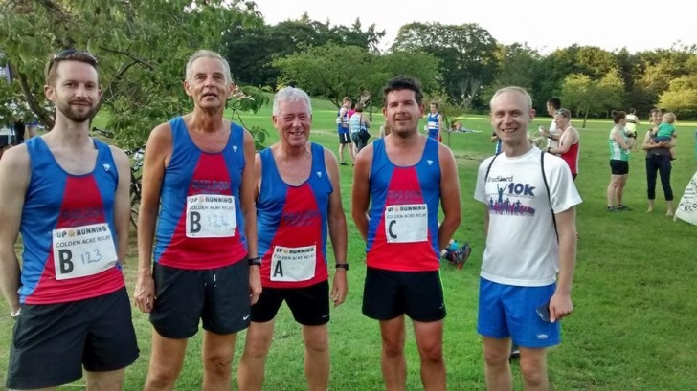
Welcome to the August edition of your Newsletter. I hope that you enjoy the articles.

There will be a shortened version of the Newsletter in September and you will have a Guest Editor – Alan Clements – as I will be getting married!!

If you have any feedback, please let me know by emailing news@baildonrunners.co.uk and I will do my best to incorporate into a future Newsletter.

Bingley Away Night

CONTRIBUTIONS TO THE NEWSLETTER
by Lizzie Rhodes

This newsletter has been brought to you by Phil Bland, Kevin Brain, Alan Clements, Sue Coates, Carolyn Hargreaves, Geoff Perigo, Lizzie Rhodes and Nigel Shaw. Thank you for your contributions.

Do you have an item that may be of interest to your fellow Members? You don’t need to worry about style, spelling or grammar, I will edit/amend if necessary.

Please send your contributions to news@baildonrunners.co.uk no later than Monday 1 September 2014.

Thanks.

30th ANNIVERSARY CELEBRATIONS
by Lizzie Rhodes

The Club’s 30th Anniversary celebrations will continue with a night out at the Copper Beech Club on Saturday 13th September from 7pm. There will be a buffet and disco. The cost will be £5.00 per head and guests are welcome.

There will also be a raffle. The profits from this will go towards supporting the fundraising of two of our members – Rachel Amner who is swimming the English Channel in September for Diabetes UK and Michelle Morris who is competing in the Marathon des Sables in April 2015 for the Intensive Care Foundation. I am worn out just thinking about that!

We need to know numbers for catering, therefore, if you would like to attend, please email the Club (baildonrunners@yahoo.co.uk) no later than Friday 15 August 2014.

So, come on – dust your dancing shoes off and get ready to party!!

NEW MEMBERS

We have three new members to report this month, Jane Chapman, Andrew Smith and James Wheldon. A warm welcome to you all!

PROFILES OF COMMITTEE MEMBERS

Over the next few months the Newsletter will feature profiles of your Committee Members so you know who to turn to should you have a query.
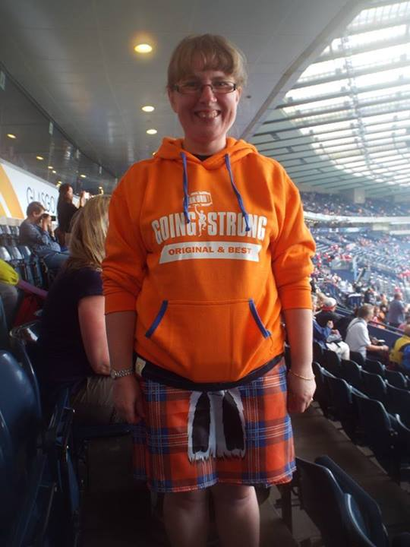
Name: Lizzie Rhodes (soon to be Smith!!)

Role on the Committee: Minutes / Newsletter

Job: Legal Assistant

When did you start running? 2009

Length of time at the Club: 4 years

Why do you run? So I can eat chocolate!!

Least favourite aspect of running: Hills / off road / mud!

First Race: Bradford 5 miles. I was very proud of the time I got only to find out later that the course had been measured short and was less than 5 miles!!

Favourite race(s): Brass Monkey Half Marathon (it’s flat!!)

Greatest Running Feat: Never having come last in a race!

Other Sports / hobbies: Wedding Planning at the moment!!

Super power you would most like to have: The ability to run!

Tell us something interesting about yourself: I am a Magistrate. I also like to volunteer at major sporting events and got the ‘bug’ after being a Games Maker at the Paralympic Games

RUNNER OF THE MONTH
Runner of the Month for June was Liz Caven for 1st F45 at the Bronte 5 Miles and organising the Family Fun Day. Liz’s prize was a bottle of wine. WELL DONE!!

Runner of the Month nominations are welcomed from all members of the Club. If you know of anyone who has made an achievement (or indeed yourselves!!), then please feel free to nominate them by emailing baildonrunners@yahoo.co.uk. It is not all about breaking records, either. It could be someone who has completed their first race at a particular distance or in a particular time. Neither, does it necessarily need to be running related. We have had winners in the past who have been awarded the accolade for volunteering at events as well as other non-running related activities.

CONGRATULATIONS – PARKRUN 100

Congratulations to Dave Shaw, who on Saturday 26th July, became the latest Baildon Runner to join the parkrun 100 club. Look out for him in his brand new running vest in the near future.

EVEN AULDER JOGGER’S BLOG!
By Phil Bland

Sad to report that Colin is still “indisposed” (or in Baildon or in trouble !) so it falls to me again to regale you with tales of derring do from the front line.

I think it was Sir Arnold Bax, the composer, who in 1943 said “You should try everything in life at least once – except incest and Morris Dancing”. Well in my humble opinion, he missed Fell Running off the list. Having seen hardy grown men with legs of steel and lungs like bellows reduced to sobbing wrecks at the end of the Burnsall Fell Race I have taken a vow of abstinence and of course tried to steer the Boss gently away from such pursuits (because I know that what she does I will be “persuaded” to follow !). So far, so good.

However last year, by one of those cruel twists of fate, the Boss won the Bradford parkrun Sweatshop runner of the month award and what does she go and buy? A pair of trail shoes. Hopefully it’s a passing phase I thought but oh no – sinister forces were at work in the shape of Denise Johnson and Anna Smith who were egging her on to have a bash at the rough stuff.

Then by another one of those horrible co-incidences she discovered the Club Off Road Summer Champs with its attendant league table where she featured having done the Ilkley Trail Race. Now give the girl a league table and I’ve lost her. This was a challenge and I could see all sorts of terrible scenarios unfolding (such as me having to actually run one of these events !)

And so it came to pass that we found ourselves at Widdop. It’s the sort of place built for breaking ankles and tearing flesh – you need a map and compass to find the start it’s so remote. The only redeeming feature I could find was that Race HQ was in a pretty nice pub. Very fortunately for me Ian Hartman had volunteered to act as race “baby sitter” for the Boss and run round with her whilst I attempted to bush whack through head high bracken to take photos – the midges were ferocious. I thought – if this doesn’t put her off nothing will.

Just over 1hr 40mins later they emerged from this jungle looking like extras from “Bridge over the River Kwai” (Ian looks a bit like David Niven on a dark night !) and when I caught up with them at the finish she uttered those dreaded words “ well I really enjoyed that “. Collapse of stout party and total failure of plan !

Now there is talk of doing the “Yorkshireman Half” and fitting in more events to get her six on the scoreboard. I think what we need is a dose of good old “Yorkshireman” weather – driving rain, sleet, low cloud etc – to dampen enthusiasm. Dave Shaw, as an ex Met Office man, I’m counting on you !

DIARY OF A RELUCTANT CLUB RUNNER
by Kevin Brain

I had a dream I was eating a giant marshmallow. When I woke up I’d gone right off my breakfast. Also, my pillow was missing and I’ve been constipated since. Thankfully, Martin Luther King didn’t go with this first draft of his famous “I have a dream” speech. Realising it didn’t set the right tone, he decided to play it straight and, inspired by his nephew’s third birthday card, went with “three at last, three at last! Thank God All Mighty I’m three at last.”
I have been contemplating the contingencies of life of late. For example, had I been born with just one of the following traits - tall, handsome, intelligent and likeable - instead of -small, freckly, sarcastic and obnoxious – I wonder how different my life would have been. Likewise, I wonder how my running would be if I had any of the following: speed, stamina, strength and will power. Sadly, we cannot all be blessed with the ability of a Coe, a Mo or a Master Po. Hold on, cancel that last one, he’s ruled out for being a panda that does Kung Fu. Anyway, I was blessed with the running genes of a dead sloth; even worse, a dead sloth with a lisp.

Which reminds me; if, like me, you do have a lisp, don’t go to Sunderland. I once went to Sunderland and, being lost, called into a fish and chip shop to ask for directions to the Stadium of Light. I asked the young girl serving for directions and she replied by asking me to order sausages. I explained that I didn’t want sausages just directions to Sunderland Stadium of Light. “Away man, say sausages” she said. She then started to shout out to other customers. It sounded to me like she was shouting “ away, listen to this man, he’s got the list”. I tried to explain that I didn’t have a list I just wanted some directions. “Away man, away man” she said, “he’s got the list. Say sausages. Go on pet, say sausages”. By now I was getting confused. Why did this woman think I had a list and why did she keep telling me to order sausages?

People were coming in off the street by now to stare at the freak with a list. They obviously don’t have TV in Sunderland. The girl went in the back to get her mum and dad (they owned the chip shop). They all started to chant “he’s got the list, he’s got the list”. “I don’t have a list” I protested, but they just fell about laughing. They kept picking things on the menu that had an S in them, like sausages and fishcakes and asking me to order them. And then the penny dropped (I must have had a hole in my pocket) and it all sthlipped into place. The girl had been saying that I had a LISP.

I realised I had become the unwitting star of some Tyne and Weird Victorian freak show. Clearly the perfect genetic gene pool that gave us Geordie Shore had never before seen a man with a lisp. I think they also still bear bait, dwarf toss and worship the sun in Sunderland. God alone knows what will happen if they meet someone with a stammer; probably burn them at the stake. Eventually, a couple of hours later, I escaped with directions and 136 sausages.
Sadly, a short while later, the chip shop burned down. I read that the police were looking for a man on the run with a list and a sausage fetish.

Speaking of being on the run, May, June and July have been really successful running months for me. I have missed nearly all race meets and club training runs. I am at my most popular with my club colleagues when I don’t turn up to anything. In fact, the only way I could increase my popularity would be to stop writing this column and agree to move to Sunderland. Dan Cobb went on a bender when he discovered he did not have to run with me in the Millenium Way Relay. He must have overdone it because he made himself ill. In fact, he couldn’t run for 3 weeks, but then who can? I’m knackered after half an hour. Anyway, nothing was making him better. The Yorkshire Vets Relay was fast approaching. Pills, potions, leeches, colonic irrigation (is there anything he won’t do for the club?), all failed. Then he discovered he was not in the same team as me and from being at death’s door he jumped into life, rose from his sick bed and banged out an 18 minute run in the Yorkshire Vets Saltaire Relay (not easy to say with a lisp!). What a miracle; Lazarus Cobb.

I briefly returned to club running at the Yorkshire Vets. I took my sick cat along but, despite there being whole teams of Yorkshire Vets, nobody could treat him. Are we sure they are all vets? I told the cat I could no longer look after him and he would go to a new owner. He also suddenly rose from his sick bed and ran round the course in 18 minutes. He moved in with Dan Cobb the following Monday.

Bionic Ben continued his unbelievable form over the summer relays. We are awaiting his drug test but suspicions are running high (just like him?). Not only does he keep talking about needing more speed but when he sees the white line at the finish, he sprints to it, bends down and tries to snort it.

Emma Stoney also ran really well. As she ran past me she said “hello Brian”. She always says this to me when we see each other running. This always surprises me because my name is Kevin. I like to think I remind her of a tall, talented, attractive runner she used to know, called Brian. Sadly not; It turns out my running reminds her of a snail; Brian, from the Magic Roundabout.

Having completed the relay I return home. I board up the cat flap and contemplate entering another race. An overwhelming feeling of being knackered hits me. I need to lie down and sleep. Then I get a text. The Club has arranged an away run in Sunderland and want me to draw up a lisp of runners. Maybe if I lie down and go to sleep when I wake up it will all have been a bad dream. Yes, I need to lie down and sleep. Now, if only I could find that bloody pillow!

INTRODUCTION TO A NEW MEMBER – NIGEL SHAW
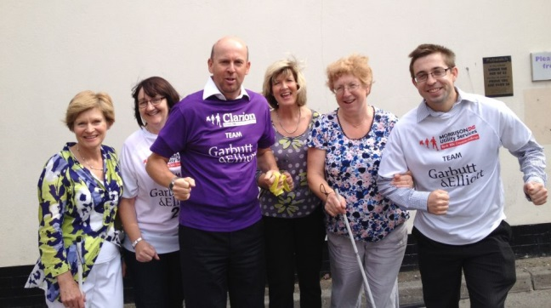
A team from leading Yorkshire accountants and business advisers Garbutt & Elliott joined forces with the York Blind & Partially Sighted Society (YBPSS) in Jane Tomlinson's Run for All York 10K on 3 August 2014.

Accountants Nigel Shaw, Jasmine Longhorne, Tom McCusker and Frances Buchanan ran the 10K with YBPSS’s Glynis Garner, Diane Roworth, Kate Collis and Teresa Mikola. Only two weeks before, 10 accountants from Garbutt & Elliott took part in the Leeds 10K.

Nigel Shaw, partner specialising in charities with Garbutt & Elliott, who have offices in York and Leeds, explained: “In the past we have raised money for the Society by running the 10K in York, but this year we thought we would do something different. We thought we’d run the course with them.

“Our four runners will team up with four members of the Society, with each runner accompanying a member of the Society to make sure they are safe. The YBPSS are one of our nominated charities for 2014 and, as well as helping them run the York 10k, we will be manning a bucket collection at York station later in the year”.

Nigel explained: “In addition, members of staff are providing pro-bono support for the Society on finance, payroll & IT matters, which is all part of our firm's developing Corporate Social Responsibility policy.
“York Blind and Partially Sighted Society are a thriving, self-governing local charity, working to help people with sight problems be independent. The York-based charity provide information, practical help and support for visually impaired people and their carers. With over 100 volunteers we are very happy to be supporting such a great charity,” added Nigel.
Diane Roworth of York Blind and Partially Sighted Society, said: “We are absolutely delighted that staff from Garbutt & Elliott are running with four of our members this year. We really appreciate their enthusiasm and willingness to help our local charity – and we ourselves are looking forward to the challenge.”
In addition to running with members of YBPSS, Garbutt & Elliott will be raising money for York Mind and Candlelighters. It is hoped the company will raise over £1,000 from the Leeds and York 10Ks.

To support the team please visit the fundraising page at: https://www.justgiving.com/teams/garbutt-elliott-2014
For more information please contact Nigel Shaw, the team representative for Garbutt & Elliott, on 01904 464100 or nshaw@garbutt-elliott.co.uk.

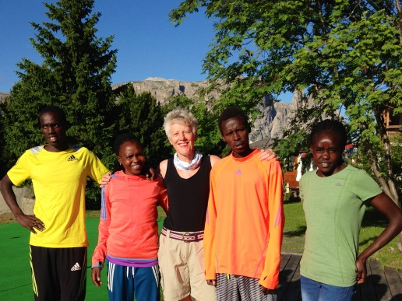CAROLYN AND THE KENYANS
By Carolyn Hargreaves
On our recent walking holiday in the Dolomites (with Inn Travel recommended by Liz Caven …brilliant holiday company!!) we met a junior Kenyan marathon team with their Italian trainer who were staying at the same hotel in a place called Compatsch. I took the opportunity to have my photo taken with them sporting my Over the Odda buff!! They are a lovely group of young people and I will look out for them in the future.

THURSDAY NIGHT RUNNING GROUPS
by Sue Coates

Below is a list of the volunteers to lead the Thursday night groups D and E:

Date Group D Group E
14/08/14 John Crabtree Jackie Walters
21/08/14 Geoff Perigo Sally Gavaghan
28/08/14 Linda Carey Dave Lonsdale
04/09/14 Phil Worsley Carolyn Hargreaves
11/09/14 Paul Baildon Ian Ferris

I realise it is holiday time, if any of the above dates are not convenient to you and you can’t get in touch with someone to swap with, just let me know and I will sort it out, it won’t be a problem.

SUNDAY SESSIONS
by Lizzie Rhodes

Due to the Summer Championships there will a limited number of led Sunday sessions over the next couple of months. Please see the rota below.

Date Leader Date Leader

17 August 2014 Dave Lonsdale 5 October 2014 Horsforth 10K
24 August 2014 Birkenshaw 5 Miles 12 October 2014 Geoff Perigo
31 August 2014 Leeds Country Way Relay 19 October 2014 Dave Lonsdale
7 September 2014 Kate Walters 26 October 2014 Wistow 10K / Bradford Half
14 September 2014 Spen Greenway 10K Marathon
21 September 2014 Warrington Half Marathon 2 November 2014 Carolyn Hargreaves
28 September 2014 Dan Cobb 9 November 2014 Dan Cobb

SUMMER CHAMPIONSHIP
by Alan Clements
Only two events in the Summer Championship in July, the Eccup 10 Miles and the Harrogate 10K. This takes us beyond the half-way mark, but, with your best six results counting, there is still time to get yourself into the competition.

In the Premier Division a good PB by Barbara Lee in the Eccup 10, has propelled her to the top of the table, closely followed by Debbie Bland, who finished in top place in both races. Paul Baildon is in third place, but has only completed five races so far. Lorne McNeill also achieved an age graded PB at Eccup, but is not troubling the leaderboard, as yet.

In the First Division, Neil Fairburn had PBs in both events and this has pushed him into the lead. Liz Caven remains in second place, closely followed by Nigel Shaw, who finished in top position in the Eccup 10 and Dave Lonsdale, who moved up the table, thanks to a PB in the Eccup 10. Melanie West also achieved a new age graded PB in the Eccup 10.

In the Second Division, there has been little change, despite Sally Gavaghan finishing in top spot in both events. She is now only 10 points short of achieving the maximum 216 points available, but I am sure another top spot, with PB, will come before the end of the season. Behind her, it is very close, with Sarah Terry, Joanne Bloor and Karen Baildon all separated by only 5 points.

The full tables can be found on the website and have also been posted in the Rugby clubhouse and changing rooms.
I believe that all of the previous errors in the tables have now been sorted, but If you feel that any of your results seem to be incorrect, please contact me and I will investigate.

SUMMER CHAMPIONSHIP RACES 2014

The remaining races in the Summer Championship are as follows. Please note the change of date for the Birkenhsaw 5 Miles and Horsforth 10K races.

Date Event Distance Date Event Distance
24 August Birkenshaw 5 miles 26 October Wistow (Selby) 10K
14 September Spen Greenway 10K 26 October Bradford ½ Marathon
5 October Horsforth 10K 11 October Bradford Parkrun 5K
21 September Warrington ½ Marathon

SPORTSSHOES.COM CONCESSION

Sportsshoes.com are keen to continue their relationship with the Club following the closure of their Bradford superstore. They are offering a concession to members purchasing online or by phone by way of a promotional code that you will need to key in at the checkout stage or quote over the phone. The code to use throughout August is (reserved for members) and entitles you to 10% off and free standard P&P. A new code will be supplied for September via email. This will ensure it stays exclusive to our Club members.

Please note that the reduction does not show on the pricing screen nor the order confirmation and that sportsshoes.com request credit card authorisation for the full amount. What happens is that the reduction is applied manually after they take the order and hence you should be getting the reduced price.

AGE CATEGORY RECORDS

This information will now be accessed through the website at www.baildonrunners.co.uk

RESULTS ROUNDUP – JULY 2014
by Phil Bland

With summer in full swing our runners have been enjoying a busy month in some terrific weather.

First out of the blocks on 9th July was the Hyde Park Summer Mile – a measured mile event run by Hyde Park Harriers on the Leeds parkrun course. Six of our milers made the trip on a glorious Wednesday evening with plenty of Club records falling in the process – Natalie Bottomley headed our speedy sextet with 6:31 in Wave 4 followed by Don Johnson in 6:37. Debbie Bland was next home achieving her sub 7 minute target with 6:57. Denise Johnson (7:16) Dave Lonsdale (7:21) and Phil Bland (7:41) completed our results with Natalie, Dave, Denise and Don all setting new Club mile records. Fastest miler on the night was J Wardman of Rothwell (4:42:09) and first lady miler was Hannah Holroyd in 5:20:07

Our very own Baildon Canter was next up on another glorious summer Saturday 12th July. In a well attended event (46 runners) sixteen of our finest set off on the blast to the Trig Point and back. Quentin Lewis broke the course record with a blistering 19:31 followed by Gareth Holme and Chris Burke on 22:25 and 22:56. Ben Watson posted a fine 23:20 closely followed in by Clive Turner on 23:38 and Emma Stoney – 2nd lady (24:09). The full results – including those for the junior race - can be found on the Club website.

Having warmed up nicely at the “Canter” the following day brought on the Eccup 10 Mile Road Race hosted by Abbey Runners. This event has gained a reputation for warm running conditions and this year’s event was no exception. With Yorkshire Vets prizes also at stake there was stiff competition. Eighteen Baildon Runners turned out for this Summer Championship race and were led home by Lorne Mc Neil in 1:09:07 with Ben Watson and Phil Brown also posting good times (1:13:09 & 1:13:27). Rebecca Langdon was our first lady home in 1:20:32 closely followed by Debbie Bland on 1:20:34 (1st FV60 & Yorkshire Vets prizewinner). Special mention must go to Jackie Walters who came home in 1:40:13 to post a new 10 mile FV65 Club Record and claim 1st FV65 in the race. The race was won by Nat Williams in a terrific time of 54:05 and first lady home was Fiona Davies (FV40) of Kingstone Runners in 1:03:57.

On 16th July three of our intrepid off roaders made the trip to the Widdop Fell Race – a tough 7 Mile event held on the wild Pennines above Hebden Bridge. Gareth Holme posted a fine 1:01:56 to dead heat for 25th place with Ian Hartman helping Debbie Bland round to her first ever proper Fell Race finish in 1:40:43. Winner was Darren Kay in 51:35, first lady Lucy Collins (Stainland) in 1:02:24. Team Prizes went to Wharfedale (mens) and Calder Valley Fell Runners (Ladies).

Only two days later our runners were in action again – this time at the Washburn Valley Relays, a very popular series hosted by Otley A.C. Baildon had two teams running, defending some great prize winning results from 2013. Sadly, despite some great performances on the night, Baildon Mixed (Emma Stoney, Quentin Lewis and Gareth Holme) couldn’t quite repeat last year’s heroics, posting an aggregate time of 21:21 for the three legs with Baildon Timber (Ben Watson, Paul Baildon & Dave Long) also running well for an aggregate of 25:41. With 56 teams competing it was a tough night with the winning Otley A.C. team posting an impressive 18:16 for the three leg aggregate time.

Hot on the heels of the relays, the Bingley Show Trail Race took place on the 19th July with four of our runners in action – Robin Graham leading us home with a 57:38, Jim Goddard (1:00:21), Kate Walter (1:14:33) and new Club member Sarah Cheshire posting a terrific 1:19:30 on this challenging course.

The very next day there were two main events to report – the Leeds 10k – with Mel West (48:46) and Amanda Darbyshire (55:50) flying the flag for Baildon. Nat Williams – winner at Eccup - popped up again as race winner in 31:43 with Pauleen Munro (Wetherby) taking out the ladies prize in 35:34

Running at the same time was the Harrogate 10k – a summer championship race – eight of our running family reported for duty on a very warm day. Phil Brown led the charge for home in 43:53 closely followed by Neil Fairburn in 47:29. A fine run by Debbie Bland (47:42) saw her lift the 1st FV60 prize whilst John Cawley (49:16), Phil Bland (58:31) and Sally Gavanagh (58:36) all posted good times in the conditions. Special mention must go to Sue Coates coming back to racing after injury (54:48) and Elinor Newhouse running her first competitive 10k in 1:06:33. Overall top of the pile was Marc Scott of Richmond & Zetland in 30:55 with Sharon Barlow of Ripon RR taking the ladies’ prize in 36:40.

23rd July saw the Golden Acre Relays take place – a record entry of 142 teams with Baildon fielding four teams. Baildon Misfits (Steve Watkins, Emma Stoney and Quentin Lewis) finishing in 15th place in 50:56, Baildon Flyers (Gareth Holme, Danny Mills and Ben Watson) 29th in 53:20, Baildon Belles (Denise Johnson, Debbie Bland and Rebecca Powell) 89th in 1:04:34 and Baildon Chippendales – yes, we all ran like furniture ! (Phil Bland, John Crabtree and Don Johnson) in 110th place in 1:09:15. Winners were City of Leeds (43:49)

To round off a busy month in fine style, the Saltaire Shaker 15k took place on 27th July attracting a record entry and some stiff competition for the nine Baildon Runners taking part. On another warm and humid day our runners rose to the occasion by posting no less than five new Club records at this distance. Neil Fairburn ran a terrific 1:15:57 to claim a new MV50 Club record, likewise, Claire Greenwood finishing just behind in 1:17:11 to post a new FV45 Club record and win 1st FV45 on the day. Jim Goddard (1:18), John Crabtree (1:21:04), Ian Hartman (1:21:37) all posted good performances, John claiming another new Club record at MV55. Not to be outdone, the ladies also bagged some records and prizes with Denise Johnson (1:22:44) posting a new FV55 record and bagging 1st FV55 on the day, and new member Jane Chapman running her first race for the Club claimed the FV40 record in 1:26:40 running alongside Hester Stefanuti (1:26:39). Linda Carey also ran a fine 1:41:34 to complete a satisfying day out for Baildon Runners.

A quieter month at Bradford parkrun this month after the flurry of PBs in June but there have been some fine performances from Ben Watson running consistently around the 20 minute mark and PBs on 12th July for Sarah Cheshire (30:43) and Elinor Newhouse (31:13) – her sixth in seven parkruns. There must have been something in the air on 12th July – just two days after her birthday Debbie Bland took out the FV60 course record at Skipton parkrun in 23:17 !

And finally !

One fine result that escaped last months net – in the Wharfedale Three Peaks Challenge on 28th June Ian Ferris, Phil Jones and Shelagh Hopkinson tackled the tough 22 miles with 4,744 feet of ascent. Ian posted a terrific 4:38:07 – sadly I don’t have a time for Phil (let me know Phil and it will go in next time) and Shelagh did the time honoured sensible thing and walked the course !

My apologies if I have missed anyone out – please e mail me with additions / corrections etc on the results email service via the web site.

QUOTE OF THE MONTH

"Running is the greatest metaphor for life, because you get out of it what you put into it."
Oprah Winfrey

FORTHCOMING RACES

Mostly there is a hyperlink to a website or email address but where there isn’t, this is usually because the entry form is not yet available.

Every Saturday Lister Park 5K parkrun (Bradford), Hyde Park 5K parkrun (Leeds), Roundhay Park 5K morning at 9:00 parkrun (Leeds), Temple Newsam 5K parkrun (Leeds), Cross Flatts Park 5K parkrun (Beeston, Leeds)
All are free events, but you must pre-register online by 6:00pm Friday, and take the barcode emailed to you.

Every Sunday Otley Chevin Forest Park 3 miles
morning at 10:30 Free event, but you must pre-register and take the barcode emailed to you.

17 August | Wagon & Horses Half Marathon (Lancaster) | 28 September | Yorkshire Vets Cross Country  Championships (Nunroyd Park,  Guiseley)
23 August | Burnsall 10 miles
23 August | Honley 10K (nr. Holmfirth)
24 August | Birkenshaw 5 Miles (SC Event) | 28 September | Great Yorkshire 10K (Sheffield)
24 August | Fleetwood Half Marathon | 5 October | Horsforth 10K (SC Event)
24 August | Escrick 10K (nr. York) | 5 October | Burnley Fire 10K
31 August | Leeds Country Way Relay | 5 October | Cusworth 10K
31 August | Blackpool Hilton Half Marathon | 12 October | Withins Skyline 12K, 300m ascent
31 August | Wetherby 10K |  | (Penistone Hill Country Park,
14 September | Spen Greenway 10K (SC Event) |  | nr Haworth)
14 September | Garstang Half Marathon | 19 October | Woodland Challenge 6 miles approx.
21 September | English Half Marathon (Warrington) |  | (Huddersfield)
 | (SC Event) | 26 October | Bradford Half Marathon (SC Event)
21 September | Lancaster Castle Half Marathon
21 September | Lancaster Castle 10K

COMMITTEE MEMBERS

Alan Clements | Secretary, Joint Club Liaison and BBWay Race Director
Dave Lonsdale | Treasurer, Membership Secretary & Curry Nights
Kevin Brain | To be announced
Sue Coates | Social Secretary, Carnival Canter & Kit
Dan Cobb | Announcements & WYWL rep
Ian Ferris | Club Coach, Beginners, Run England & BAN Rep
Matthew Gurney | Development Group Link, AA Link and BBWay Entries Secretary
Gareth Holme | Men’s Relay Team Captain
Geoff Perigo | Webmaster, Club diary & routes
Lizzie Rhodes | Minutes and Newsletter
Tracy Robinson | Assistant Social Secretary
Emma Stoney | Ladies’ Relay Team Captain

OTHER CONTACTS

Paul Baildon | Club Auditor
Richard Barnes | Garmin routes
Liz Boothman  Phil Bland | Schools Liaison  Club Records
Chris Burke | BBWay Course Marshall
Colin Davidson | T & A reports
Hamid Houman | BBWay Course Director
Denise Johnson | Veterans
Michelle Morris | BBWay Chief Marshal
Anna Smith | Off-Road Leagues

WEBSITE AND EMAIL ADDRESSES

Website: | baildonrunners.co.uk
General email: | baildonrunners@yahoo.co.uk
Newsletter email: | news@baildonrunners.co.uk
Results email: | results@baildonrunners.co.uk

